Picture Rotation Activity #11:
Mental rotation exercises were inspired by the classic work done by Roger Shepard and Jacqueline Metzler in 1972. In 1982, Shepard and Lynn Cooper reported that the number of degrees an image is rotated is related to how long it takes to complete the activity, which indicates that people are actually rotating it in their mind. In a subsequent study, it was found that mentally rotating objects primarily involves the use of the right parietal lobe as well as the occipital lobes. Mental rotation activities exercise our visual spatial abilities.

Picture Rotation Activity #11:

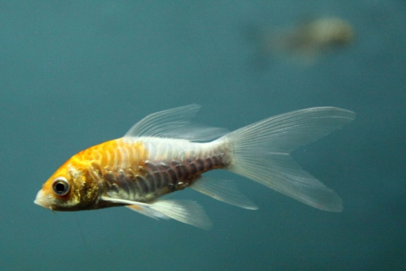
Use the image above the line to figure out which image below is a “rotated” copy of the above image.

_

___________________________________________________

1. 2.

3. 4.

Picture Rotation Activity #11: SOLUTION

3.

