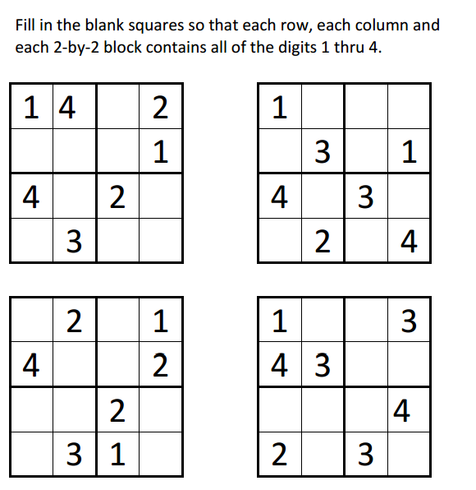
Sudoku Activity #16:

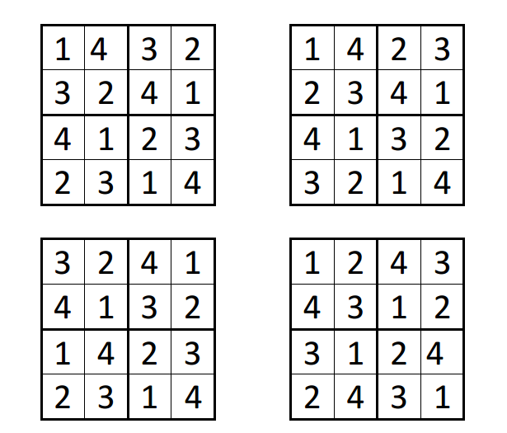
Sudoku Activity #16: SOLUTIONS

