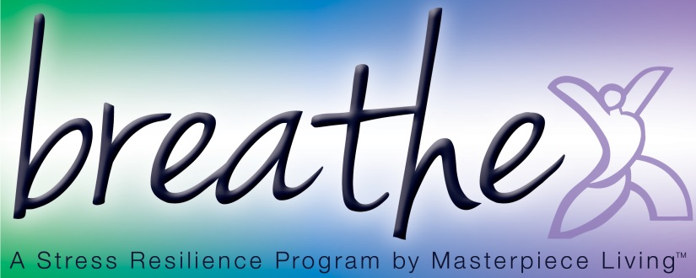
Session 1: Breathing Exercise
Breathing is one of the simplest ways we can increase stress resilience. By consciously breathing, we bring energy and oxygen to all the parts of the body, helping to physically relieve stress. By practicing some type of relaxation exercise on a regular basis, we create an opportunity for the body to recover from the impacts of repeatedly activating the stress response throughout the day. The more you practice, the easier your body finds this place of balance and relaxation, which increases your stress resilience over time.
Take a moment to adjust yourself so that you are sitting comfortably in your chair, feeling as supported as possible.
You may close your eyes, if you feel comfortable doing so. Or you may choose to just gently gaze downward toward the floor.
Gently bring your attention to your breath. Not changing anything about it but simply “watch” or notice your breath. Letting go of thoughts and emotions for just a moment, using the breath as a focal point for the mind.
Pay attention to the inhale and the exhale.
Follow the breath as it moves in through your nostrils, past your throat, into your lungs, and toward the stomach.
Follow your breath as it releases from your stomach, through the lungs, past the throat, and out of your nostrils.
Simply follow the breath. Maybe you “name” it as it occurs.
Inhale
Exhale
Inhale
Exhale
Now see if you can allow yourself to relax with each exhale, releasing tension, feeling yourself become more supported by the chair at each point of contact.
Simply sit in silence with your breath for 2 minutes, gradually increasing this amount of time as you begin to feel more comfortable with the exercise. Simply “be” with the pattern of your own breathing, without changing it or doing anything.
At the end of your breathing exercise, gently begin to transition by deepening your breath.
Slowly and gently bring attention back to your body by gently wiggling fingers and toes, slowly and gently stretching as you feel inspired.
And when you’re ready, slowly shift your attention back to the room by blinking your eyes, softly gazing at the floor at first, then gradually bringing your attention fully into the room.

