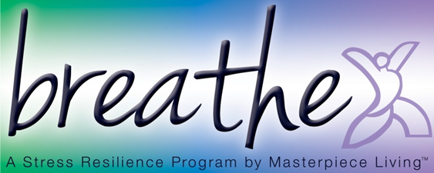
Session 1: Breathing Exercise (script)
Breathing is one of the simplest ways we can increase stress resilience. By consciously breathing, we bring energy and oxygen to all the parts of the body, helping to physically relieve stress. By practicing some type of relaxation exercise on a regular basis, we create an opportunity for the body to recover from the impacts of repeatedly activating the stress response throughout the day. The more you practice, the easier your body finds this place of balance and relaxation, which increases your stress resilience over time.
Take a moment to adjust yourself so that you are sitting comfortably in your chair, feeling as supported as possible.
Now, I invite you to close your eyes, if you feel comfortable doing so. Or you may choose to just gently gaze downward toward the floor.
Gently bring your attention to your breath. Not changing anything about it but simply “watch” or notice your breath. Letting go of thoughts and emotions for just a moment, using the breath as a focal point for the mind.
Pay attention to the inhale and the exhale.
Follow the breath as it moves in through your nostrils, past your throat, into your lungs, and toward the stomach.
Follow your breath as it releases from your stomach, through the lungs, past the throat, and out of your nostrils.
Simply follow the breath. Maybe you “name” it as it occurs.
Inhale (pause several seconds)
Exhale (pause several seconds)
Inhale (pause several seconds)
Exhale (pause several seconds)
Now see if you can allow yourself to relax with each exhale, releasing tension, feeling yourself become more supported by the chair at each point of contact.
Now I am going to let you simply sit in silence with your breath for 2 minutes. Simply “be” with the pattern of your own breathing, without changing it or doing anything. I’ll gently remind you when the minute is complete.
(Sit silently for 2 minutes while participants observe their breath)
(Gently)
Now gently bring your attention back to the sound of my voice.
I invite you to begin deepening your breath.
Slowly and gently bring attention back to your body by gently wiggling fingers and toes, slowly and gently stretching as you feel inspired.
And when you’re ready, slowly shift your attention back to this room by blinking your eyes, softly gazing at the floor at first, then gradually bringing your attention back to the group.
(Allow another minute for the group to transition from breathing exercise back to the group.)

