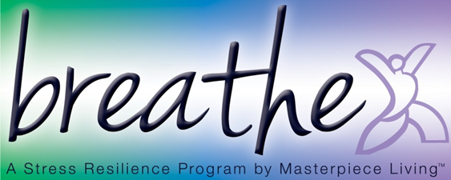
Session 2: Breathing Compassion (script)
This breathing exercise is based on an approach called Tonglin. Tonglin is Tibetan for “giving and taking”. The basis of the meditation is that we have the ability to transform negative emotions into positive ones, while increasing our compassion for ourselves and others. It may be helpful to simply practice level one for several sessions, until you feel comfortable. Then, you may build on that foundation with option 2 and/or option 3, as it feels right for you. Today, I will introduce all 3 of the options. Please remember it is always your choice to participate as we move through the levels.
Take a moment to adjust yourself so that you are sitting comfortably in your chair, feeling as supported as possible.
Now, I invite you to close your eyes, if you feel comfortable doing so. Or you may choose to just gently gaze downward toward the floor.
Before we begin, please take a moment to consider a recent situation that has caused you stress. Then, identify the emotion associated with it (anger, frustration, sadness, loneliness, etc).
In a moment, we will revisit that emotion and practice a technique to transform it. But for now, let’s gently bring attention to the breath. Not changing anything about it but simply “watch” or notice your breath. Letting go of thoughts and emotions for just a moment, using the breath as a focal point for the mind.
Pay attention to the inhale and the exhale.
Inhale (pause several seconds)
Exhale (pause several seconds)
Inhale (pause several seconds)
Exhale (pause several seconds)
Now with each inhale, imagine breathing in the emotion you identified earlier. Feel your heartache or frustration with someone.
With each exhale, imagine breathing out love, clarity, and compassion to both of you.
Inhale feeling the anger, frustration, or sadness.
Exhale love, clarity, and compassion to both of you.
Now I’ll be silent while you practice that for 2-3 breaths
(Pause and allow group members time to complete 2-3 full rounds of breath)
Now, we are going to build on that, for those of you who are ready. You may also choose to just continue practicing the technique we just learned.
For the second level of compassion training we will inhale the pain of someone you know.
Exhale compassion, light, calm, and a blessing for that person.
Again, on the inhale, breathe in the pain of another person.
Exhale compassion, light, calm, and a blessing for that person.
Now I’ll be silent while you practice that for 2-3 breaths; again, you may choose to work with the first option or the second option. Your choice.
(Pause and allow group members time to complete 2-3 full rounds of breath)
Now we are going to take it one step further. Again, you may choose to stay with either the first or second option. Those who are ready may want to try this third option.
As humans, we all experience a range of emotions. For this part of the exercise we are going to practice connecting to the universal human experience.
On the inhale, breathe in the pain of all who have similar frustration and conflicts.
Exhale compassion, love, and a blessing to all in conflict.
Again, inhale, breathing in the pain of all who have similar frustration and conflicts.
Exhale compassion, love, and a blessing to all in conflict.
Now I’ll be silent while you practice that for 2-3 breaths; again, you may choose to work with the first option, the second option, or the third option; whatever feels most appropriate for you.
(Pause and allow group members time to complete 2-3 full rounds of breath)
(Gently)
Now gently bring your attention back to the sound of my voice.
I invite you to begin deepening your breath.
Slowly and gently bring attention back to your body by gently wiggling fingers and toes, slowly and gently stretching as you feel inspired.
And when you’re ready, slowly shift your attention back to this room by blinking your eyes, softly gazing at the floor at first, then gradually bringing your attention back to the group.
(Allow time for the group to transition from breathing exercise back to the group.)

