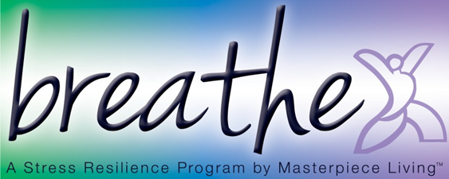
Session 2: Breathing Compassion
This breathing exercise is based on an approach called Tonglin. Tonglin is Tibetan for “giving and receiving”. The basis of the meditation is that we have the ability to transform negative emotions into positive ones, while increasing our compassion for ourselves and others. It may be helpful to simply practice level one for several sessions, until you feel comfortable. Then, you may build on that foundation with option 2 and/or option 3, as it feels right for you.
Take a moment to adjust yourself so that you are sitting comfortably in your chair, feeling as supported as possible.
You may close your eyes, if you feel comfortable doing so. Or you may choose to just gently gaze downward toward the floor.
Take a moment to consider a recent situation that has caused you stress. Then, identify the emotion associated with it (anger, frustration, sadness, loneliness, etc).
Opening:
In a moment, we will revisit that emotion and practice a technique to transform it. But for now, let’s gently bring attention to the breath. Not changing anything about it but simply “watch” or notice your breath. Letting go of thoughts and emotions for just a moment, using the breath as a focal point for the mind.
Pay attention to the inhale and the exhale for a few moments.
Option 1:
Now with each inhale, imagine breathing in the emotion you identified earlier. Feel your heartache or frustration with someone.
With each exhale, imagine breathing out love, clarity, and compassion to both of you.
Inhale feeling the anger, frustration, or sadness.
Exhale love, clarity, and compassion to both of you.
Practice this for a few breath cycles.
Option 2:
For the second level of compassion training we will inhale the pain of someone you know.
Exhale compassion, light, calm, and a blessing for that person.
Again, on the inhale, breathe in the pain of another person.
Exhale compassion, light, calm, and a blessing for that person.
Practice this for a few breath cycles.
Option 3:
As humans, we all experience a range of emotions. For this part of the exercise we are going to practice connecting to the universal human experience.
On the inhale, breathe in the pain of all who have similar frustration and conflicts.
Exhale compassion, love, and a blessing to all in conflict.
Again, inhale, breathing in the pain of all who have similar frustration and conflicts.
Exhale compassion, love, and a blessing to all in conflict.
Practice this for a few breath cycles
Closing:
Now gently bring your attention back to the room.
You may begin to deepen your breath.
Slowly and gently bring attention back to your body by gently wiggling fingers and toes, slowly and gently stretching as you feel inspired.
And when you’re ready, slowly shift your attention back to this room by blinking your eyes, softly gazing at the floor at first, then shifting your attention back to the room.

