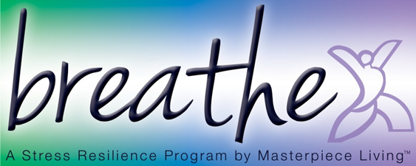
Session 4: Guided Imagery
Guided Imagery is a technique for drawing on the senses to create a peaceful place in your mind, where you can go for relaxation. Just as your brain is triggered into the stress response by thinking about stressful situations, so too, does thinking about a peaceful environment trigger a relaxation response to counter the impacts of stress. Harnessing this unique and powerful ability of the brain is an effective way to increase stress resilience. The more frequently you practice, the more benefits you will experience.
Find a comfortable place where you may sit or lie down, with your spine as straight as possible, feeling completely supported, in a quiet room where you will not be interrupted.
Gently bring your attention to your breath. Not changing anything about it but simply “watching” or noticing your breath. Allow yourself to let go of thoughts and emotions for just a moment, using the breath as a focal point for the mind. You might envision these thoughts floating past, like a leaf on a river.
Paying attention to the inhale and the exhale, allow yourself to release any remaining tension in the body and adjust as needed in order to be as comfortable as you possibly can be. With every inhale feeling your body expand, and with every exhale, feeling even more relaxed.
Now, inviting your mind to create a place where you feel completely safe and comfortable. This might be a place you have been or somewhere you would like to go, somewhere real or imagined, it doesn’t matter as long as you feel at peace here.
You might envision an open meadow, a damp forest, a sunny beach, or a cozy cottage. Whatever setting feels most comfortable for you, indoors or out, warm or cool, dry or damp. Once you have located this place in your mind, take a moment to look around you, taking in the colors, the textures, the foreground, and the background. Look to your left, your right, up, and down. Just taking in everything you see with your eyes. Noticing how you enter and exit your special place, noticing that you are completely safe, that no one else may enter without your permission.
Taking a moment to notice the smells within your special place. A fire in the fireplace, the ocean air, the meadow flowers or cookies baking in the oven. Just taking in the fragrance of the place.
Now using your sense of touch to explore being in the place. What is beneath you, supporting you. Are you standing, sitting, or lying down. Noticing the air on your skin, warm, cool, breezy, still. Just taking in the tactile sensations of the place.
Noticing the sounds of the place. A babbling brook, a crackling fire, gentle waves, complete silence, or chorus of sounds. Just taking in all the sounds in your peaceful place.
Now, taking in the sensation of feeling completely relaxed, completely safe, completely at peace in your special place. Simply taking in the experience, allowing yourself to revel in this moment.
Knowing you can come back here whenever you choose, that this place is always available only to you, that you may choose to replenish yourself by visiting as often as you like.
Gently preparing yourself to let go of your place for now, noticing how you exit the place, leaving it gently behind you, ready and waiting for your next visit.
Slowly and gently bringing your attention back to your breath, slowly beginning to deepen your breath, gradually bringing movement into the body – wiggling fingers and toes, wrists and ankles, and maybe stretching a bit if that feels good to you. Gently allowing yourself to transition back into this room by slowly blinking your eyes open to gaze softly downward, then gently, when you’re ready, bringing your attention back to the room.

