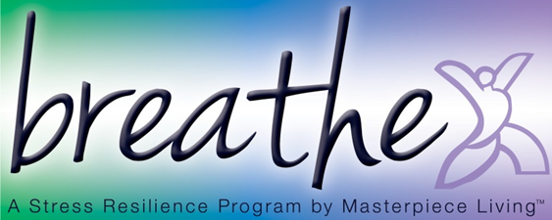
Session 3: Progressive Muscle Relaxation (PMR)
Progressive Muscle Relaxation is a technique where you focus on individual muscle groups, tensing and relaxing them one at a time. It is helpful for a variety of ailments, but can be particularly useful for letting go of stress from the muscles at the end of the day, before falling asleep. A typical session of PMR lasts at least 20 minutes, but this abbreviated version is something you will be able to practice at home.
Find a comfortable place where you may lie down, feeling completely supported, in a quiet room where you will not be interrupted.
Please skip any muscles that are injured or painful. When you tense, do so without straining. On the release, let all the tension out at once. You might find it helpful to repeat to yourself “I am relaxing” or “I am letting go”.
For each muscle group listed below
- “tense”
- hold 7-10 seconds
- “relax”,
- repeat for a total of 2-3 times per muscle group before moving to the next
Abbreviated Muscle Groups
Eight Muscle Group
1. Both hands and lower arms
2. Both legs and thighs
3. Abdomen
4. Chest
5. Shoulders
6. Back of neck
7. Eyes
8. Forehead
Take a moment now, to simply feel your body. Notice any changes that occurred during this exercise. Let’s sit for a moment in silence, allowing us to mindfully observe our newfound state of relaxation.

