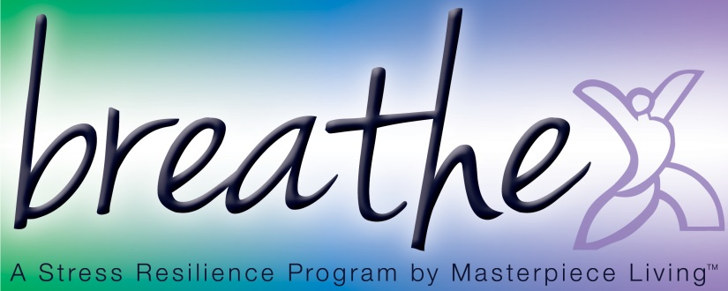
Session 3: Progressive Muscle Relaxation (PMR) (script)
Progressive Muscle Relaxation is a technique where you focus on individual muscle groups, tensing and relaxing them one at a time. It is helpful for a variety of ailments, but can be particularly useful for letting go of stress from the muscles at the end of the day, before falling asleep. A typical session of PMR lasts at least 20 minutes, but today we are just going to have an introduction to the technique and this abbreviated version is something you will be able to practice at home.
Take a moment to adjust yourself so that you are sitting comfortably in your chair, feeling as supported as possible, with both feet on the floor. When you are at home, the ideal position for PMR is laying down.
Now, I invite you to close your eyes, if you feel comfortable doing so. Or you may choose to just gently gaze downward toward the floor. As I name each muscle group we are going to tense the muscles that I name, hold for a few seconds, and then relax.
Please skip any muscles that are injured or painful. When you tense, do so without straining. On the release, let all the tension out at once. You might find it helpful to repeat to yourself “I am relaxing” or “I am letting go”.
Let’s begin… (for each muscle group listed below, cue “tense”, wait 7-10 seconds, “relax” repeat for a total of 2-3 times per muscle group before moving to the next, depending upon what time allows)
Abbreviated Muscle Groups
Eight Muscle Group
1. Both hands and lower arms
2. Both legs and thighs
3. Abdomen
4. Chest
5. Shoulders
6. Back of neck
7. Eyes
8. Forehead
Take a moment now, to simply feel your body. Notice any changes that occurred during this exercise. Let’s sit for a moment in silence, allowing us to mindfully observe our newfound state of relaxation.
Now gently bring you attention back to the sound of my breath. I invite you to begin deepening your breath. Slowly and gently bring attention back to your body by gently wiggling fingers and toes, slowly and gently stretching as you feel inspired.
And when you’re ready, slowly shift your attention back to this room by blinking your eyes, softly gazing at the floor at first, then gradually bringing your attention back to the group.
(Allow time for the group to transition from exercise back to the group.)

