Want to learn how to sparkle under stress?
Sign up for the newest version of Breathe: A Stress Resilience Program by Masterpiece Living
Contact ________________to sign up today!
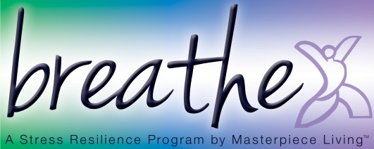
Date/Time:

