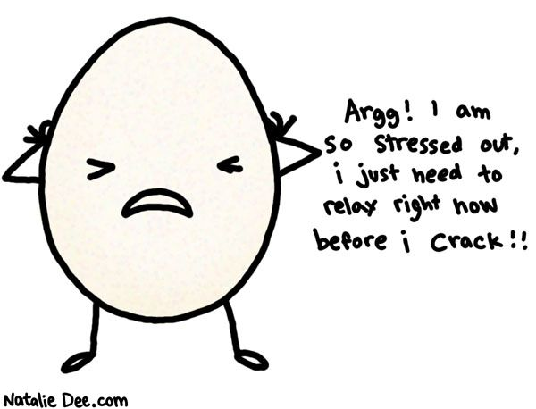
Sign up for the newest version of Breathe: A Stress Resilience Program by Masterpiece Living and learn ways to keep your fragile shell in one piece.
Contact ________________to sign up today!
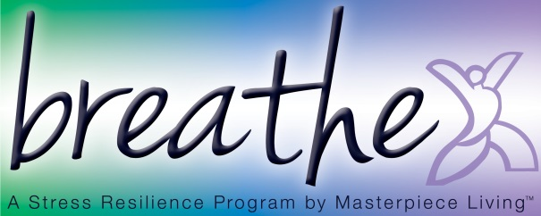
Date/Time:

