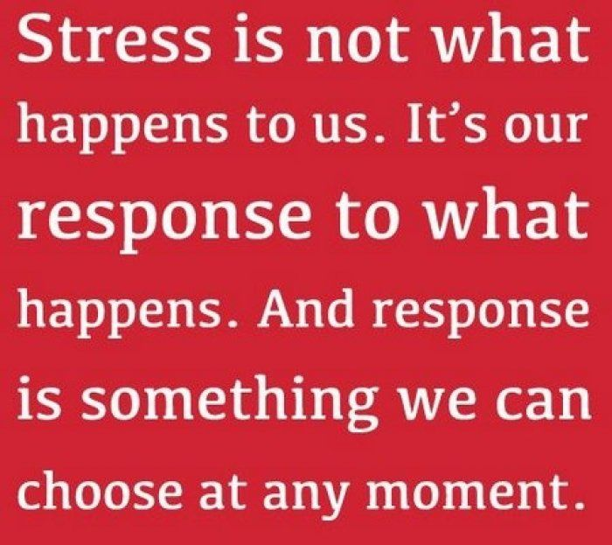
Sign up for the newest version of Breathe: A Stress Resilience Program by Masterpiece Living and learn how your response to stress can have a profound effect on your health.
Contact ________________to sign up today!
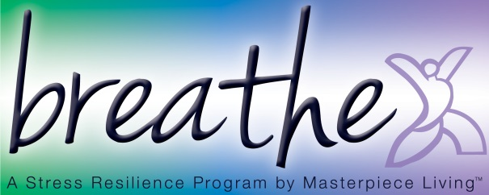
Date/Time:

