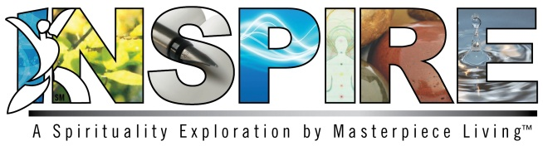
Dear Inspire Facilitators,
It is with great pleasure that we welcome you to Inspire, a five-session spirituality exploration by Masterpiece Living which addresses the themes of mindfulness, peacefulness, compassion, acceptance and purpose through engaging discussions, prayers, meditations and guided activities. The program was designed to promote spiritual growth and help define what it means to be spiritual in both religious and non-religious contexts. Developed with both residents and staff in mind, participants are encouraged to utilize the concepts provided in the program and apply them to their own spirituality and personal practices.
Why be spiritual? Research suggests that spiritual people are happier, healthier and experience better relationships and a greater sense of purpose.
As facilitators of Inspire, you will be introducing each topic with a brief PowerPoint presentation followed by several group activities related to the session theme. You are encouraged to utilize as many of the prayers, meditations and activities as you see fit. Likewise, we encourage you to adapt the talking points and exercises as appropriate for the group. Please provide each participant with an Expressions of Spirituality Guidebook for personal use throughout the program and for future reflection.
Inspire is intended to provide participants with a safe spiritual space to explore, grow and embrace diversity of thought and conversation. Please keep in mind that you may hear opinions that differ from your own. As facilitators, we ask that you remain respectful of people’s beliefs, keep an open mind and an open heart, and encourage participants to do the same. You are also part of the spiritual journey!
We also ask that you recognize that spirituality can be a private matter for some people. Certain participants may not feel comfortable sharing their opinions on particular topics. Please make sure that each participant understands that choosing NOT to share is perfectly acceptable as well.
To begin, we encourage you to refer to the Preparation Pages for each session found within this Facilitator’s Guidebook as you plan and prepare for facilitating the program.
It is with deepest gratitude that we thank you for fostering spiritual growth with this Masterpiece Living program. Once again, we welcome you to the exciting world of Inspire!

Best Wishes,
- The Masterpiece Living Team

