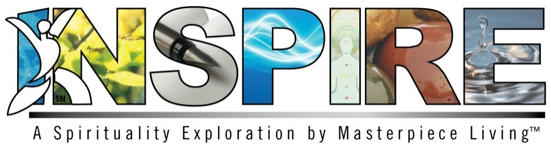

Dear Inspire Participants,
It is with great pleasure that we welcome you to Inspire, a five-session spirituality exploration by Masterpiece Living that addresses the themes of mindfulness, peacefulness, compassion, acceptance and purpose through engaging discussions, prayers, meditations and guided activities. The program was designed to promote spiritual growth and help define what it means to be spiritual in both religious and non-religious contexts. You are encouraged to utilize the concepts provided in the program and apply them to your own spirituality and personal practices.
Why be spiritual? Research suggests that spiritual people are happier, healthier and experience better relationships and a greater sense of purpose.
Each session, the program will explore a new theme of spirituality with a brief PowerPoint presentation followed by several group activities. Some of these activities include moving to music, prayers and devotionals, becoming a poet laureate, sharing family traditions, getting out in nature and exercises in expressing gratitude. Please use your Expressions of Spirituality Guidebook for personal use throughout the sessions and for future reflection and practice.
Inspire is intended to provide a safe spiritual space to explore, grow and embrace diversity of thought and conversation. Please keep in mind that you may hear opinions that differ from your own. We kindly ask that you remain respectful of people’s beliefs, keep an open mind and an open heart. We are all a part of this spiritual journey.
We also recognize that, for some people, spirituality is a private matter. If you do not wish to share your thoughts and opinions with your group, this is perfectly acceptable as well.
We thank you for your participation as we explore spiritual growth together. Once again, we welcome you to the exciting world of Inspire!
- The Masterpiece Living Team

