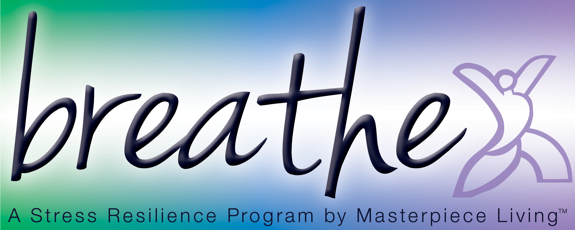
Compress and De-Compress Meditation
I’d like you to sit comfortably in your chair, either cross-legged (if that’s comfortable for you) or with your feet on the floor, legs uncrossed and hands resting on the top of your thighs.
Close your eyes and take a few long, deep breaths, in and out, through your nose. With each exhale, allow yourself to sink into your chair, feeling completely supported.
As you inhale, use your mind’s eye to watch the breath move through the back of your throat and down to about two inches below your navel. Pause at the top of that breath, and watch the air as it leaves your body on the exhale, as if you were watching a wave on the ocean rise and fall.
Continue watching your breath, noticing the inhalation and the exhalation.
Take a moment to scan your body from head to toe. If you notice any areas of tension, see if you can begin to inhale oxygen into those spaces where you find resistance. On the exhale, soften those areas and allow the tension to melt into the floor.
Then return to watching your breath.
We received a wealth of new information today, and our minds are likely buzzing as we try to process it all. Recognize that by quieting our minds, we will naturally process all of the information we received today without having to replay that information over and over again. For now, allow your mind to relax.
With each exhale allow your body to soften a little more into your chair.
If you notice thoughts surfacing, gently acknowledge them without judgment, and simply return to watching your breath – noticing your inhalation and exhalation.
With a deep sense of peace, watch the breath as you inhale, this time allowing that peaceful energy to move through your entire body, including your arms and legs and your mind.
As you exhale, allow mind and body to relax a little more deeply.
I am going to remain silent for the next few minutes. With your eyes closed, continue to watch your breath for as long as you wish, inhaling peaceful energy. And then, when you are ready, let the image go and allow your mind to become quiet.
Slowly begin to bring your awareness back into the room. Open your eyes.

