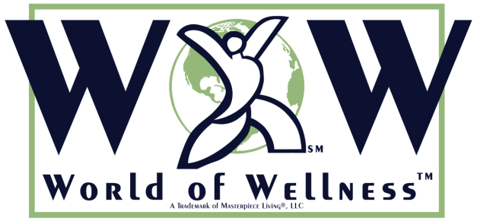

WORLD OF WELLNESS
World of Wellness (WoW) is a seven-week, turnkey Program by Masterpiece. It focuses on the four Masterpiece components and how these shape other cultures around the world. This program looks at the seven continents and 6 different countries from each continent (Japan, Italy, Canada, Chile, New Zealand, Kenya and Antarctica). WoW is different from other Programs by Masterpiece in that it is a program that aims on educating people about aspects of culture from different countries around the world rather than educate on one specific topic such as brain health or fall prevention. WoW is a fun and entertaining program that enlightens people on the topic of cultural diversity.
The program comes with a presentation (PPT format) complete with presenter notes that the facilitator can read to the class, a preparation page for each unit, a quiz game to follow each presentation (Jeopardy! Structure in PPT format), and various activities such as word scrambles and crossword puzzles.
Ideally, WoW would go great with a themed initiative where communities would focus on one country a week or one a month, and directors would supplement WoW with other activities such as guest speakers from that country or who have visited the country, games/activities native of that country, themed dinners, resources from the greater community, etc. Please understand that a program like this takes a good deal of planning and work, so please allow yourself plenty of time to plan and prepare so that it will be successful.

