Homework Assignment #3:

Word Scramble: States of the Union 1 (Easy)
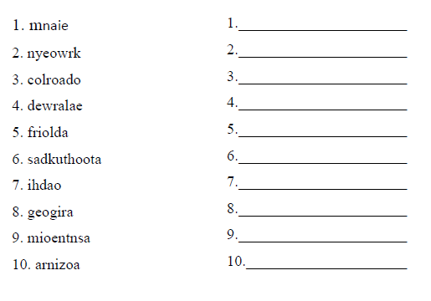

Word Scramble: States of the Union 2 (Easy)
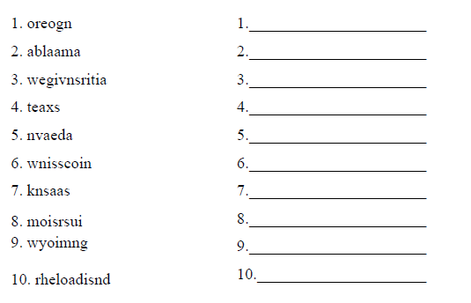

Word Scramble: States of the Union 3 (Easy)
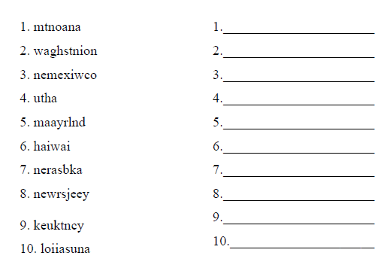

Word Scramble: States of the Union 4 (Easy)
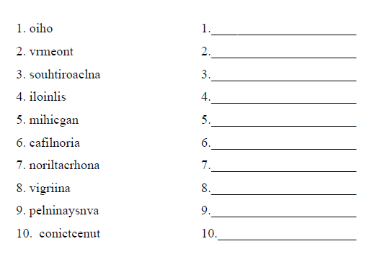

Word Scramble: States of the Union 5 (Easy)
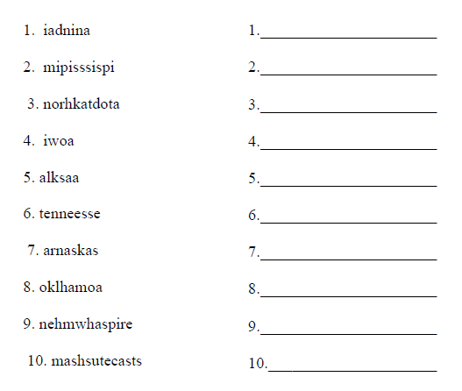

Word Scramble: States of the Union 1 (Difficult)
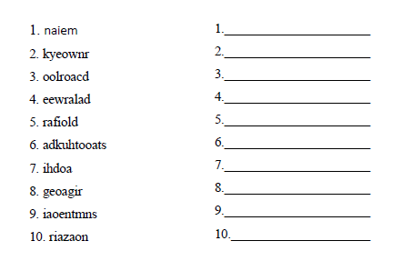

Word Scramble: States of the Union 2 (Difficult)
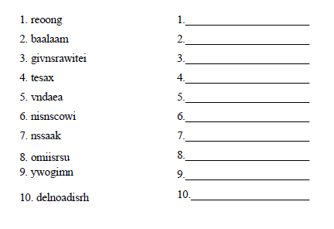

Word Scramble: States of the Union 3 (Difficult)
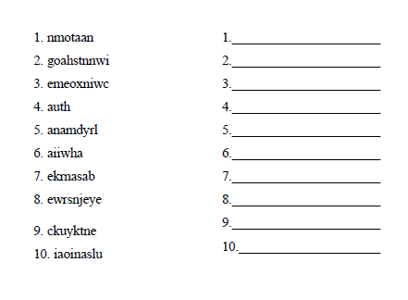

Word Scramble: States of the Union 4 (Difficult)
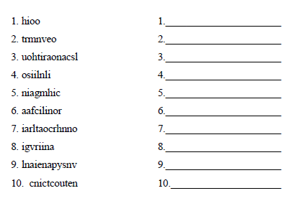

Word Scramble: States of the Union 5 (Difficult)
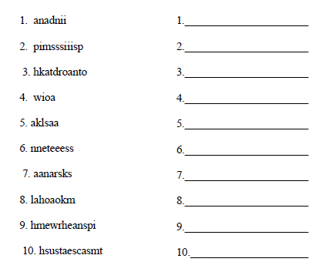

Homework Assignment #3: ANSWERS

Word Scramble: States of the Union 1 (Easy and Difficult)
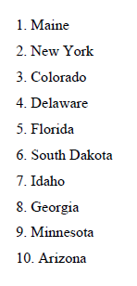

Word Scramble: States of the Union 2 (Easy and Difficult)
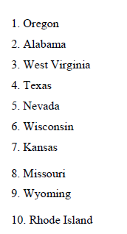

Word Scramble: States of the Union 3 (Easy and Difficult)
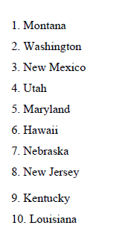

Word Scramble: States of the Union 4 (Easy and Difficult)
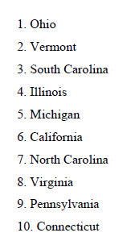

Word Scramble: States of the Union 5 (Easy and Difficult)
