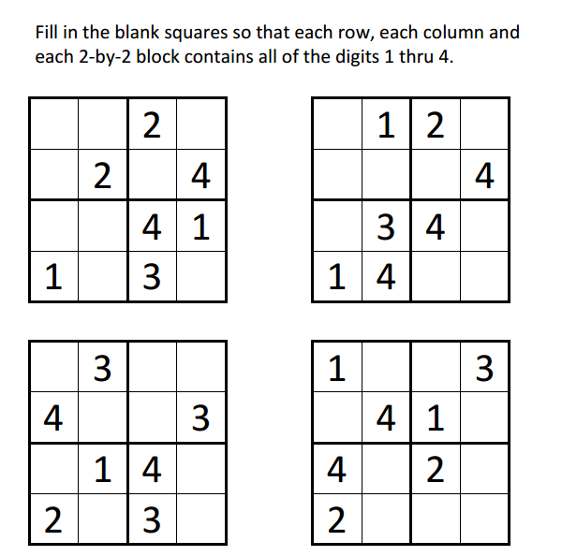
Sudoku Activity #15:

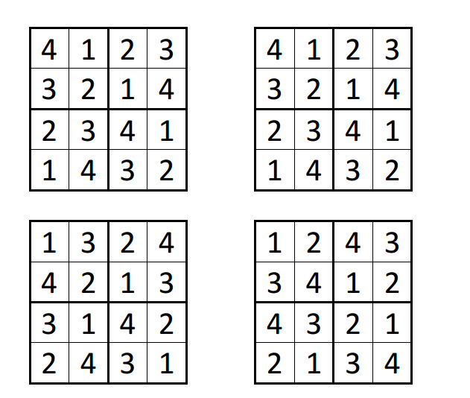
Sudoku Activity #15: SOLUTIONS

