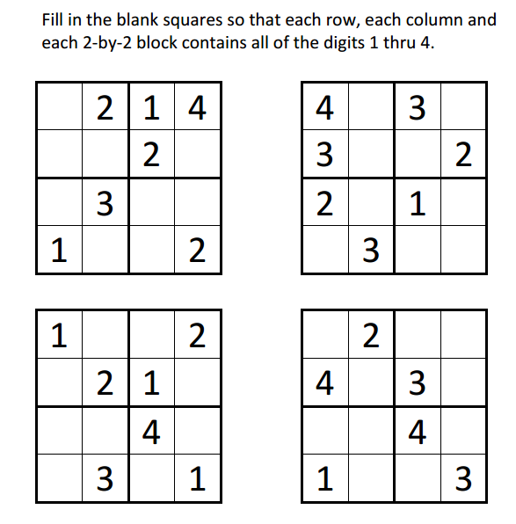
Sudoku Activity #17:

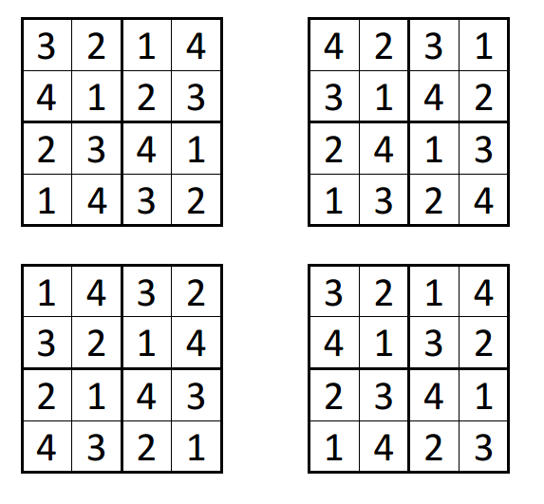
Sudoku Activity #17: SOLUTIONS

