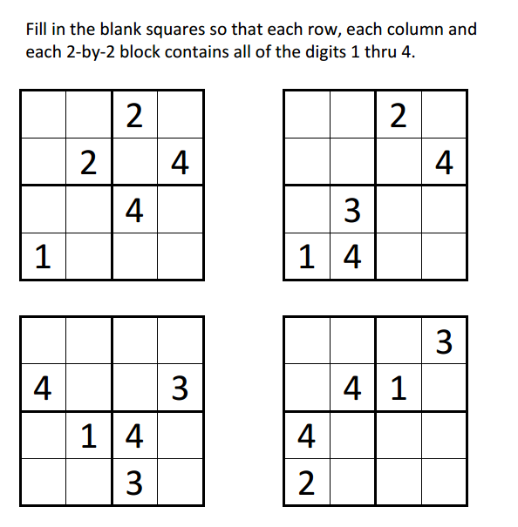
Sudoku Activity #18:

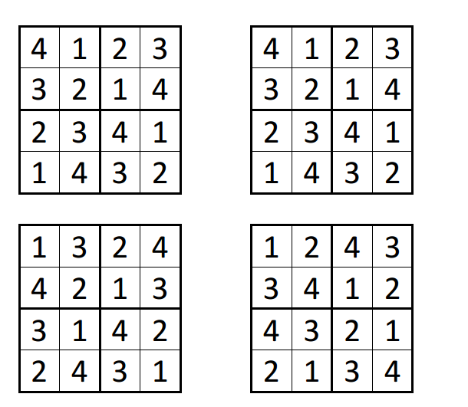
Sudoku Activity #18: SOLUTIONS

