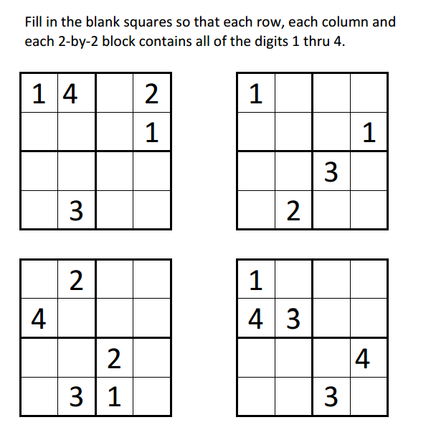
Sudoku Activity #19:

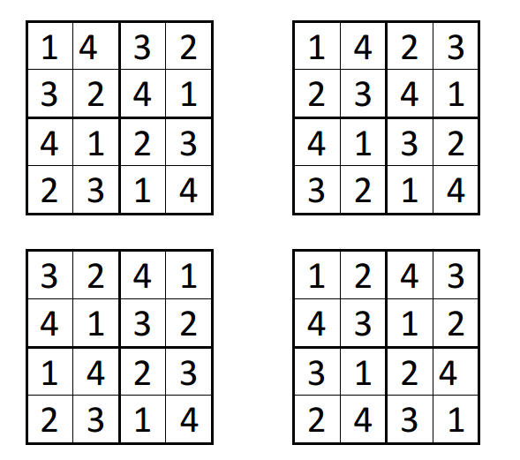
Sudoku Activity #19: SOLUTIONS

