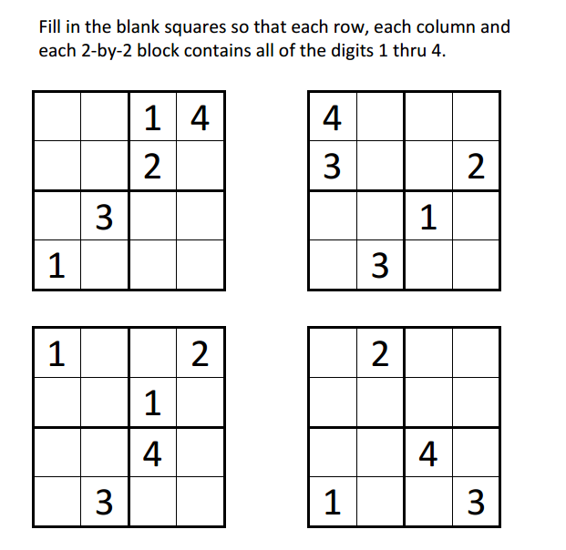
Sudoku Activity #20:

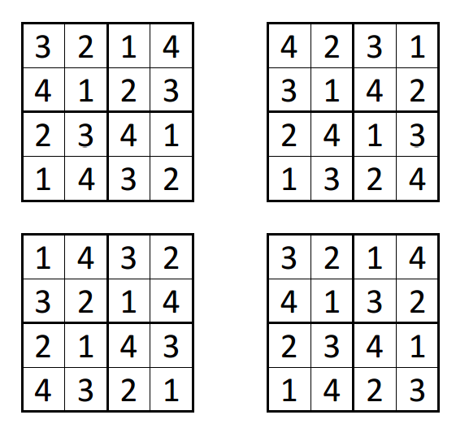
Sudoku Activity #20: SOLUTIONS

