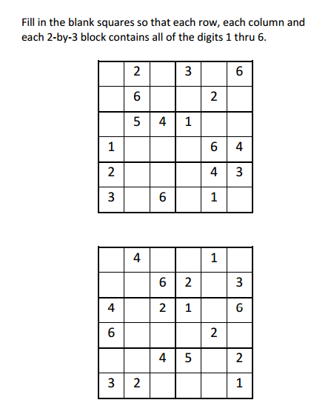
Sudoku Activity #21:

Sudoku Activity #21: SOLUTIONS

