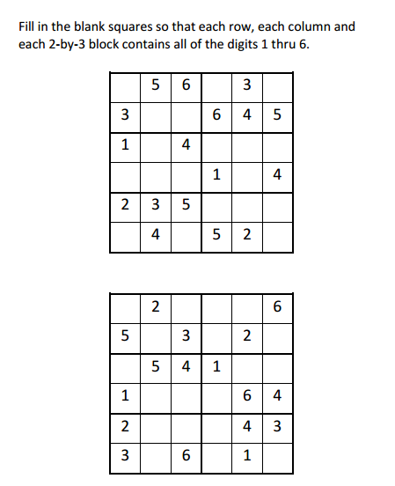
Sudoku Activity #22:

Sudoku Activity #22: SOLUTIONS
