Sudoku Activity #23:
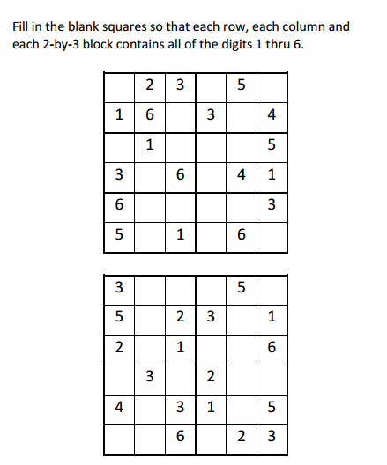

Sudoku Activity #23: SOLUTIONS
