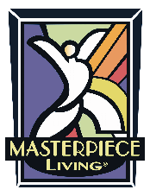
[Community Logo]

[DATE]

Dear Resident,

We are continuing our successful aging journey. The time has come to participate in the Annual Masterpiece Lifestyle Review. Developed by Dr. Robert Kahn, the co-author of Successful Aging, and other experts on the Masterpiece Living team, the Lifestyle Review examines your overall wellness across the physical, social, intellectual, and spiritual realms. The MacArthur research on successful aging found that 70% of how we age depends on the lifestyle choices we make every day. Even more exciting, the researchers determined that it’s never too late to make choices that will lead to aging more successfully. So maybe you’re asking yourself, “Why should I choose to participate in the Lifestyle Review”? Let us explain….
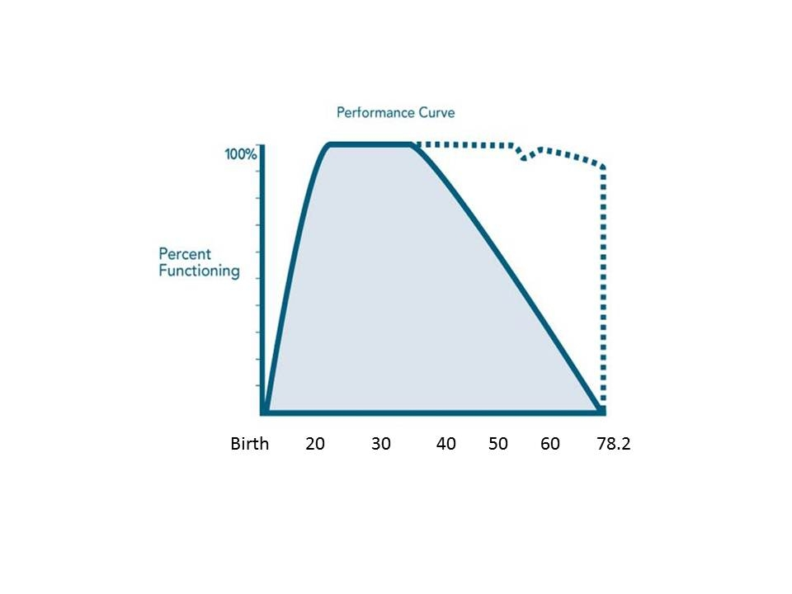

This graph tells us a story about successful aging. This solid line represents the idea we have of usual aging, where we grow and then gradually decline over time. This period of decline is usually filled with chronic disease and gradually decreasing function and independence. At some point along this line, an older adult may be faced with needing assistance and can no longer function independently.

The dotted line represents successful aging and that it is possible for the majority of people if they make good choices in their lives. You can see that for those who age successfully, the period of high physical and mental function extends and the process of death is relatively short – it’s not a long, drawn-out and miserable process.

Participating in the Lifestyle Review provides three important benefits:

- First, you will take charge of your aging experience.
Receive a confidential snapshot of your lifestyle as it relates to the concepts of successful aging. The information provided will serve as a springboard for actions in your life. The Review will provide you with a baseline, offering an opportunity to track your progress annually thereafter. The goal is that you maintain and/or improve your results year after year.

- Second, you are helping your community.
By participating in the Lifestyle Review, [COMMUNITY NAME] is provided with aggregate results of the Lifestyle Review that will help to direct the programs and events in our community. By no means is your individual information shared. All Lifestyle Reviews are confidential and will only provide [COMMUNITY NAME] with overall data, not specific names.

3. Third, you are contributing to a growing body of knowledge.
Participation in the Lifestyle Review will help to build the data of the entire Masterpiece Living Network that can be drawn from. Masterpiece Living uses this national data to examine patterns in lifestyle and extract data revelations on topics such as factors impacting fall risk, spirituality, emotional health, self-reported health, etc. Masterpiece Living releases these data revelations to the network as well as the industry to educate and inform. With time, Masterpiece Living hopes to use the data to impact health care costs & savings to bring preventative wellness to all older adults – in communities, in their homes, etc.

It’s never too late to begin making lifestyle choices that research has shown are most likely to result in successful aging, but don’t delay! Ask yourself, “What do I want my future to look like?” Participating in the Lifestyle Review begins a successful aging journey that is proven to reap many wonderful benefits.

Help us reach our goal of at least [insert goal] participants!!!

If completing the review by pencil and paper method, please return your completed Lifestyle Review to [LOCATION] in the confidential envelope you received no later than [DATE]. If you would like to complete the review on-line, if you would like assistance in completing the Lifestyle Review or have questions, please feel free to contact us.

By turning in the Lifestyle Review by [DATE] you will receive [INCENTIVE].

ALL residents that complete the review this year will be entered into a drawing to win [INCENTIVE]!

[CONTACT INFO]

