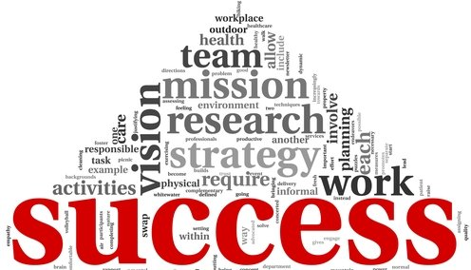

Are You Already Doing It?
8 Ways to Tell if Your Organization is Committed to Successful Aging
By: Teresa Beshwate, MPH

Successful aging … The term itself has been around for decades and yet still prompts discussion about whether it is the ideal terminology. Given this, it is not surprising that there is a wide range of understanding about what successful aging means, at both the individual and organizational levels. With a surface level understanding, it is tempting to say “I’m already doing it,” or at the organizational level, “We already do that.” Yet, a closer look at what successful aging means individually and organizationally will redefine the term and likely reveal that there is ample room for growth, and that the pursuit of successful aging is truly a continuum, a journey with no end point.

A deeper understanding of successful aging brings about an important realization: there is so much room for growth and suddenly no room for a “been there, done that,” sentiment. Resting on the laurels of perceived success no longer becomes an option. We simply have to be willing to take a closer look and challenge our own current definition.

Individually, to age successfully means maintaining high physical and mental function, active engagement with life and lowering the risk of disease and disease-related disability. Decades of research shows that this lifestyle dramatically impacts one’s ability to live well and die short, and suggests that it is never too late to begin such lifestyle habits and still realize results. At the individual level, successful aging means constantly growing and challenging oneself in pursuit of the lifestyle that research shows results in a successful aging experience.

Applying those research findings at the organizational level has been the work of Masterpiece Living since 1999, with the goal to create environments that promote and support such lifestyle choices. The definition of successful aging at the organizational level has evolved ever since, with the bar being raised constantly.

Eight Ways to Tell if Your Organization is Truly Committed to Successful Aging

By today’s standards, the organization fully committed to successful aging...

- … has examined every element of culture through the lens of successful aging, including language, operations, policies, procedures, physical environment and inclusive practices for all levels of living.
- … has leaders who constantly reexamine and modify nearly all leadership practices and duties to directly support successful aging.
- … aggressively challenges stereotypes about aging and positions itself as a local expert on successful aging and a thought leader in the aging field.
- … places equal emphasis on team members’ successful aging as it does for older adults.
- … inspires older adults to become engaged leaders in all successful aging offerings.
- … measures successful aging at the individual and organizational levels.
- … offers only programming that is purposeful, engaging and challenging.
- … measures its growth systematically, and uses these measures as a basis for ongoing growth.

Despite these efforts, even these organizations never claim to be “doing it,” because they realize that successful aging is a continuum of ongoing organizational growth. Although they pause to celebrate successes, they are certain that the greatest achievements are still to come. They ask “Why not?” as they set new standards, and they learn from others who have blazed different trails. Organizations committed to successful aging are ever hungry for continued growth and equally generous in sharing what they’ve learned so that – collectively – we can change the experience and perception of aging in our society. Is your organization doing that?

