The Live Long, Die Short Book Club Facilitator’s Guide
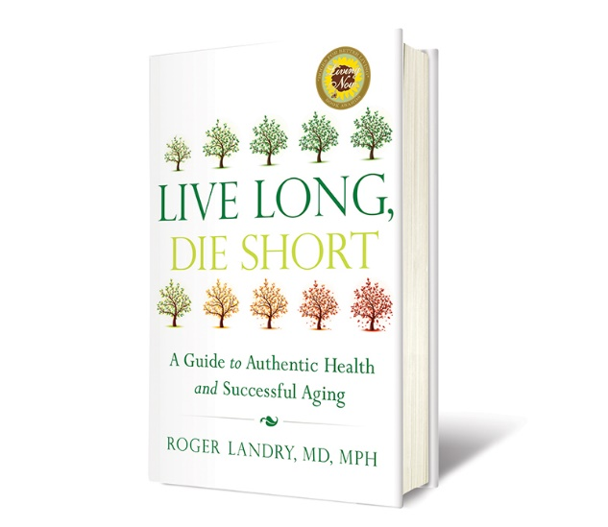

Introduction (to be read to the group)
Welcome to the Live Long, Die Short Book Club. Dr. Roger’s book provides a definitive roadmap to healthy longevity. It is a pivotal call to action for individuals, organizations, and communities to assimilate the optimistic new findings on aging into all they do.
Whether you’ve already read the book or are just getting started, you are already part of a movement to apply this new knowledge about what is possible as we age – not only to your own life but also to the lives of others.
Today, we’re going to get the conversation started with a few discussion questions about Authentic Health and Successful Aging.
Before we begin, let’s take a moment to discuss a few guidelines:
Please be respectful. Each person in this room comes from a different background that has formulated who they are as a person and contributed to their unique opinions. As a group, we will observe respect as a guiding principle as we interact with one another. It is our goal that all participants feel valued, respected and heard.
Share without imposing your beliefs on others. We also ask that each person takes responsibility for their own opinions and agree to refrain from convincing others to adopt these opinions.
Keep an open mind. Our discussions will be thought-provoking and insightful. You may not agree with everything you hear, but please be willing to consider opinions that may be different from your own.
  - Facilitator’s Note: Please feel free to use as many or as few of these questions as you like or add your own. We have also provided a few talking points to keep the conversation moving.

Discussion Questions:

- How many have already read Dr. Roger’s book, Live Long, Die Short? Of those who have read it, can you briefly share your overall thoughts about the book?

- Why do you think Dr. Roger chose the title Live Long, Die Short?

- What is your favorite take-away from the book? (Talking Points: Finding purpose, learning to control stress – remember the zebra story?)

- In Chapter One, Dr. Roger introduces the concept of Authentic Health. What does Authentic Health mean to you?

- In the book, Dr. Roger discusses the way our ancestors lived. What characteristics of their lives do you think are the keys to Authentic Health? (Talking Points: diet, movement, learning about new environments, social connectedness)

- What concerns you about the way we live today? How does the way many live detract from being Authentically Healthy? (Talking Points: stress, technology, diet, lack of mobility, isolation)

- Charles Darwin said, “It is not the strongest of the species that survives, nor the most intelligent. It is the one most adaptable to change.” Why do you think people resist change?

- How do you think we can become more adaptable to change? (Talking Points: Dr. Roger argues that we struggle to reach our goals because we try to take on too much and as a society, we don’t value small changes (kaizen).)

- Dr. Roger talks about ten tips to achieve Authentic Health and Successful Aging. If you were to add Tip #11, what would it be?

- Dr. Roger implores us, “never act your age!” What does he mean by this, and why is it important? (Talking Points: If we act our age, we buy into the stereotype that aging means decline. Is it possible to not let our age and societal expectations of that age define us?)

- Does anyone have a favorite quote or story from Live Long, Die Short?

- Older adults bring a wealth of wisdom and experience to our culture. In what ways can (or have) your skills and knowledge served as a valuable resource to our community?

Conclusion:
Thank you, everyone, for being here to share your time and your thoughts with each other.
  - Facilitator’s Note: Please send any highlights from this Book Club or hot topics of discussion to Danielle Palli at Danielle@mymasterpieceliving.com so Masterpiece can gather feedback for further product development.

About Dr. Roger Landry
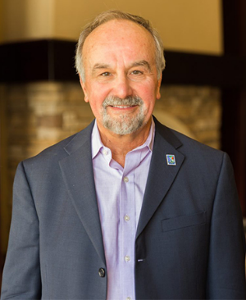
Dr. Roger Landry is a preventive medicine physician trained at Tufts University School of Medicine and Harvard University School of Public Health. Dr. Landry specializes in building environments that empower older adults to maximize their unique potential. He is currently the president of Masterpiece, a company dedicated to providing a pathway to healthy longevity. Through Masterpiece, Dr. Landry brings decades of research to life, helping senior living communities across the country to create an environment where residents are most likely to enjoy health and wellbeing, and become all they can be.
For well over a decade Dr. Landry has focused his efforts on older adults as a lecturer, researcher, consultant, and author. He is the author of the award-winning book Live Long, Die Short: A Guide to Authentic Health and Successful Aging. His book has been endorsed by AARP, was a pick of MORE Magazine, and is a winner of the Gold Medal for Living Now Awards, books for better living. Dr. Roger is the author or scores of published articles, a white paper, Where You Live Matters, and a contributing author to 80 Things to do When You Turn 80. Dr. Roger’s keynote addresses are powerful, entertaining and optimistic. He is also the host of the chart-topping podcast, Dr. Roger & Friends: The Bright Side of Longevity.

Join the Movement!
Sign up for The Bright Side of Longevity, a weekly email from Dr. Roger and a team of health and longevity experts from Masterpiece. Get a regular dose of inspirational healthy longevity tips. CLICK HERE to sign up.

Social Media Pages
Website www.livelongdieshort.com
Facebook www.facebook.com/doctorroger
Twitter https://twitter.com/livelongdieshort
Podcasts https://www.spreaker.com/show/dr-roger-friends

Order a Copy of Live Long, Die Short for yourself or a friend:
Paperback Copies: Shop Masterpiece
eBook Copies: Amazon.com

