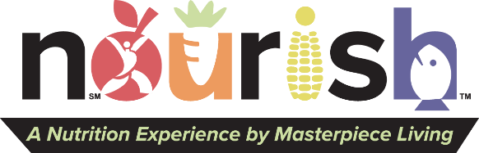
These apps are tools to help you

Wellness FX
Cost: Free
Description: Review results from your personalized health plan complete with practitioner recommendations. Create and keep track of your results and add goals to help develop and maintain healthy habits.
Benefits: Tracking your exercise and movement on apps or trackers like the one provided to you for Movement Matters, provide motivation, accountability, consistency and scheduling support.

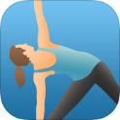 Pocket Yoga
Cost: $2.99
Description: Practice yoga with 27 different sessions varying in difficulty and duration. Learn about yoga poses with an in-app dictionary that contains explanations for correct posture, alignment and benefits.
Benefits: Yoga is a great way to get moving. Yoga increases flexibility, which helps you maintain a good range of motion, promotes good bone health and helps keep you centered and energized.

Smoothie Selector
Cost: $0.99
Description: 100 smoothie recipes from editors of women’s and men’s health magazines.
Benefits: Homemade smoothies often have less calories than store bought and can be packed with nutrients. Use these recipes to boost your consumption of fruits and vegetables.

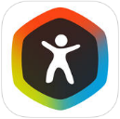 Argus
Cost: Free
Description: An all-in-one fitness app, Argus features a heart rate monitor, sleep time smart alarm clock, pedometer, GPS activity tracking and a social community.
Benefits: The social component of this app promotes connection, accountability and support throughout your fitness journey. Team up with a partner or group during Movement Matters to enhance these benefits.

Spotify
Cost: Free (Premium: $9.99/month)
Description: Stream full albums from your favorite artists, listen to pre-made playlists, or make your own playlists that motivate you to get moving!
Benefits: Music can motivate you to work harder and elevate your mood.

Headspace: Meditation Techniques
Cost: Free
Description: Meditation and mindfulness for 10 minutes a day
Benefits: Meditation promotes physical, mental and spiritual wellbeing. Physical benefits have been found in individuals experiencing stress, chronic pain, anxiety, depression, diabetes, and hypertension.

Watermind Me
Cost: $1.99
Description: Reminders throughout the day help you get your recommended daily water intake. Be reminded, input your latest water intake, repeat.
Benefits: Drinking water has many health benefits such as decreased of fatigue, regulation of body temperature during exercise, and support in flushing toxins out of the body. Drinking water is especially important when you have an increase in exercise and movement.

Tai Chi Step by Step
Cost: $4.99
Description: Step by step instructions to learn the basics of Tai Chi
Benefits: Tai Chi helps maintain balance, strength and flexibility and is often referred to as “meditation in motion”.

Sleep Cycle
Cost: $.99
Description: Track time asleep and sleep quality.
Benefits: Exercise can help you fall asleep faster and improve your quality of sleep. Track your sleep progress during Movement Matters and throughout your movement journey to see the benefits. Don’t exercise too close to bedtime or you might have too much energy to fall asleep!

iPhone Health
Cost: Free with iPhone
Description: Dashboard of your personal fitness and
health data that automatically uploads after first time
opening the app.
Benefits: Benefits of tracking without the need to activate an app.

