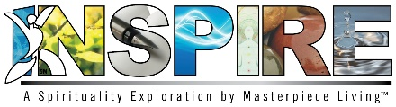
Session 1: Facilitator Preparation
Objectives:
- Define spirituality
- Discuss research related to the health benefits of spirituality and spiritual practice
- Discuss activities of spiritual and practice
- Define and experience mindfulness as a theme of spirituality and spiritual expression
- Encourage discussion of spirituality and mindfulness

Materials:
- Session 1 Power Point presentation and projector
- Print copy of Session 1 presentation for Facilitator to utilize speaker’s notes
- Participants’ Expressions of Spirituality Guidebook
- Mindfulness Prayer/Devotional (Facilitator Guidebook)
- Moving to the Music Exercise (Facilitator Guidebook)
- CD player and selection of music (see Moving to the Music exercise)
- Nature Walk Exercise (Facilitator Guidebook)
- Flip chart and marker/dry erase board and markers (Optional)

Before Class:
- Print Expressions of Spirituality Guidebook for each participant
- Print Facilitator Guidebook & Power Point presentation with speaker’s notes for facilitator use
- Gather music needed for Moving to the Music exercise
- Set up room with tables and chairs
- Set up room in a way that allows for discussion and makes it easy for everyone to see and hear the presentation
- Identify location (trail, walking path, park beach) for Nature Walk Exercise
- Encourage residents to wear appropriate footwear for Nature Walk Exercise
- Arrange transportation for Nature Walk Exercise (if needed)

Copyright © 2018 by Masterpiece Living, LLC
All rights reserved. No part of this program may be reproduced or transmitted in any form or by any means, electronic or mechanical, including photocopying, recording or by any information storage and retrieval system, without the written permission of Masterpiece Living, LLC except where permitted by law. For information address: 11360 N Jog Road, Suite 102, Palm Beach Gardens, FL 33418.

