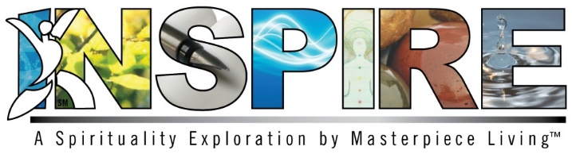
Session 2: Facilitator Preparation
Objectives:
- Review definition of spirituality
- Discuss research related to the health benefits of spirituality and spiritual practice
- Define and experience peacefulness as a theme of spirituality and spiritual expression
- Encourage discussion of spirituality and peacefulness

Materials:
- Session 2 Power Point presentation and projector
- Print copy of Session 2 presentation for Facilitator to utilize speaker’s notes
- Participants’ Expressions of Spirituality Guidebook
- Peacefulness Prayer/Devotional (Facilitator Guidebook)
- Kindness Meditation (Facilitator Guidebook)
- 5-Minute Calming Stretch (Facilitator Guidebook)
- Family Heirloom Exercise (Facilitator Guidebook)
- Gratitude Stone Exercise (Facilitator Guidebook)
- Small pebble or ornamental gemstone for Gratitude Stone Exercise
- Flip chart and marker/dry erase board and markers (Optional)

Before Class:
- Refer to participant Expressions of Spirituality Guidebook
- Refer to Facilitator Guidebook & Power Point presentation with speaker’s notes for facilitator use
- Gather small pebble or ornamental gemstone needed for exercise
- Set up room with tables and chairs
- Set up room in a way that allows for discussion and makes it easy for everyone to see and hear the presentation

Copyright © 2018 by Masterpiece Living, LLC
All rights reserved. No part of this program may be reproduced or transmitted in any form or by any means, electronic or mechanical, including photocopying, recording or by any information storage and retrieval system, without the written permission of Masterpiece Living, LLC except where permitted by law. For information address: 11360 N Jog Road, Suite 102, Palm Beach Gardens, FL 33418.

