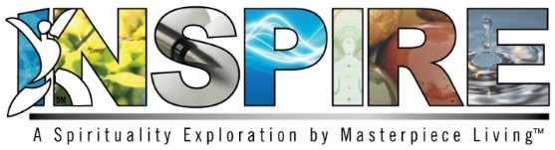
Session 4: Facilitator Preparation
Objectives:
- Define and experience acceptance as a theme of spirituality and spiritual expression
- Discuss research related to the health benefits of spirituality and spiritual practice
- Encourage discussion of spirituality and acceptance

Materials:
- Session 4 Power Point presentation and projector
- Print copy of Session 4 presentation for Facilitator to utilize speaker’s notes
- Participants’ Expressions of Spirituality Guidebook
- Acceptance Prayer/Devotional (Facilitator Guidebook)
- Drop in the Bucket exercise (Facilitator Guidebook)
- Morning Affirmation on Acceptance (Facilitator Guidebook)
- Sharing Traditions exercise (Facilitator Guidebook)
- Hot Topic exercise (Facilitator Guidebook)
- Flip chart and marker/dry erase board and markers (Optional)

Before Class:
- Refer to participant Expressions of Spirituality Guidebook
- Refer to Facilitator Guidebook & Power Point presentation with speaker’s notes for facilitator use
- Gather current newspaper clippings for Hot Topic Exercise
- Set up room with tables and chairs
- Set up room in a way that allows for discussion and makes it easy for everyone to see and hear the presentation

Copyright © 2018 by Masterpiece Living, LLC
All rights reserved. No part of this program may be reproduced or transmitted in any form or by any means, electronic or mechanical, including photocopying, recording or by any information storage and retrieval system, without the written permission of Masterpiece Living, LLC except where permitted by law. For information address: 11360 N Jog Road, Suite 102, Palm Beach Gardens, FL 33418.

