Vertical 360 Program Descriptions
These descriptions are meant to be utilized to support your marketing and promotion efforts of Vertical 360. For example, use these as turnkey elevator speeches or on marketing materials for prospective participants.

Description One: Vertical 360 is an interactive, six-session fall prevention program by Masterpiece Living.

Description Two: Vertical 360 addresses fall prevention from a 360-degree point of view. A six-session fall prevention program by Masterpiece Living, participants will discover how the SIPS of successful aging can mitigate fall risk.

Description Three: Vertical 360 is an interactive, six-session fall prevention program my Masterpiece Living. Vertical 360 reveals how just four key components of lifestyle [social, intellectual, physical and spiritual] can positively impact mobility and fall risk.
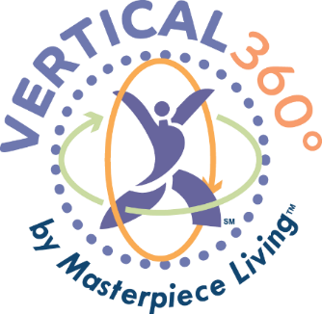

Description Four: Our Masterpiece Living Portrait report shows that [insert message here, such as fall incidence has increased, worry about falling has increased, fall risk has increased, etc.] Vertical 360 is an interactive, six-session fall prevention program by Masterpiece Living. Discover how just four key components of lifestyle [social, intellectual, physical and spiritual] can positively impact mobility and fall risk.

Description Five: [Depending on available space, insert description one, description two, description three or description four]. Participants will:

- Identify motivation to remain mobile and prevent falls
- Explore the 360 in Vertical 360
- Discuss the four components of successful aging and how they relate to fall prevention
- Gain new strategies to mitigate your fall risk and promote continued mobility
- [Optional: Transform your fear of falling with simple strategies that can dramatically reduce your fall risk]

