building brain health

brain training apps

Brain training games through apps for mobile or tablets can help you improve cognitive skills including memory, attention, processing speed, mental flexibility and problem solving.
 | Peak-Brain Training  by Brainbow |  | Geist: Brain & Mind  By Memorado
 | BrainHQ  from Posit Science |  | Vocabulary Builder  By Magoosh
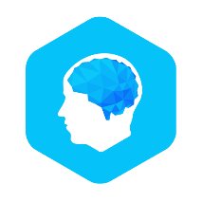 | Elevate  By Dana Nakano, PhD | 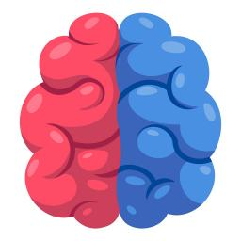 | Left vs. Right: Brain Games  By MochiBits, LLC
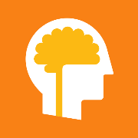 | Lumosity  By Human Cognition Project | 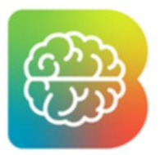 | Brainwell: Brain Training Game  By Monclarity, LLC
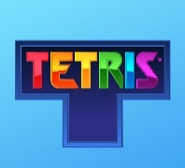 | Tetris  By Alexey Pajitnov | 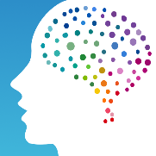 | NeuroNation-Brain Training  By NeuroNation
 | Stroop Effect  By Attila Hegedus |  | 1010!  By Gram Games
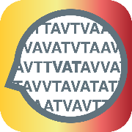 | Visual Attention Therapy  By Tactus Therapy Solutions Ltd. |  | Sudoku-Brain Puzzle Games  By Learnings.AI

