GEMS: MPL Coach Training
Customized MPL content integrated into Coach Training Alliance resources to create the following modules, available through videos on the Masterpiece Living website and through live workshops facilitated by the designated coaches on the MPL Team.
- GEMS: Introduction to Coaching
  - Define coaching – what it is and is not
  - Understand the difference between coaching, leading, and managing
  - Articulate the value of coaching and the impact on culture
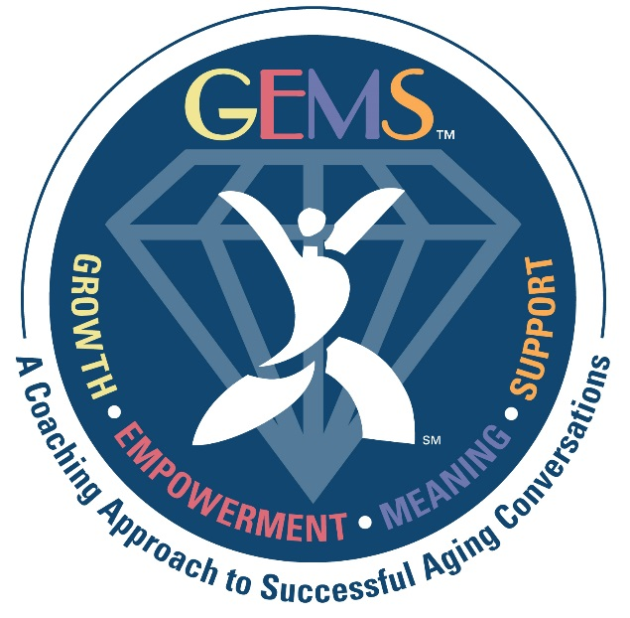
  - Determine how coaching may be used to support successful aging of residents and team members
- GEMS: Coaching Conversations
  - Define the key elements of being an effective coach
  - Understand how to ask powerful questions
  - Learn how to integrate a coaching approach into everyday conversations
- GEMS: Simple Coaching Model
  - Articulate the five steps of the Simple Coaching Model
  - Understand what the Simple Coaching Model looks like in action
  - Practice using the Simple Coaching Model
- GEMS: Facilitating Follow-up Sessions
  - Explore each step within the Follow-up Session Facilitator Agenda
  - Review necessary materials and practices required for a successful follow-up session
  - Understand how coaching skills support facilitators during a follow-up session

Two MPL Coach Levels
Emerald Level
- GEMS: Introduction to Coaching
  - Date Completed:________________ Format (circle): Video or Live
- GEMS: Coaching Conversations
  - Date Completed:________________ Format (circle): Video or Live
- GEMS: Simple Coaching Model
  - Date Completed:________________ Format (circle): Video or Live
- Polish Your GEMS (Live coaching practice facilitated by a MPL Partnership Specialist as a coach, coachee, or primary observer)
  - Date Completed:________________
  - Date Completed:________________
  - Date Completed:________________
  - Date Completed:________________
Diamond Level
Emerald Level Plus:
- GEMS: Facilitating Follow-up Sessions
  - Date Completed:________________ Format (circle): Video or Live

- Polish Your GEMS (Live coaching practice facilitated by a MPL Partnership Specialist as a coach, coachee, or primary observer)
  - Date Completed:________________
  - Date Completed:________________
  - Date Completed:________________
  - Date Completed:________________
  - Date Completed:________________
  - Date Completed:________________

