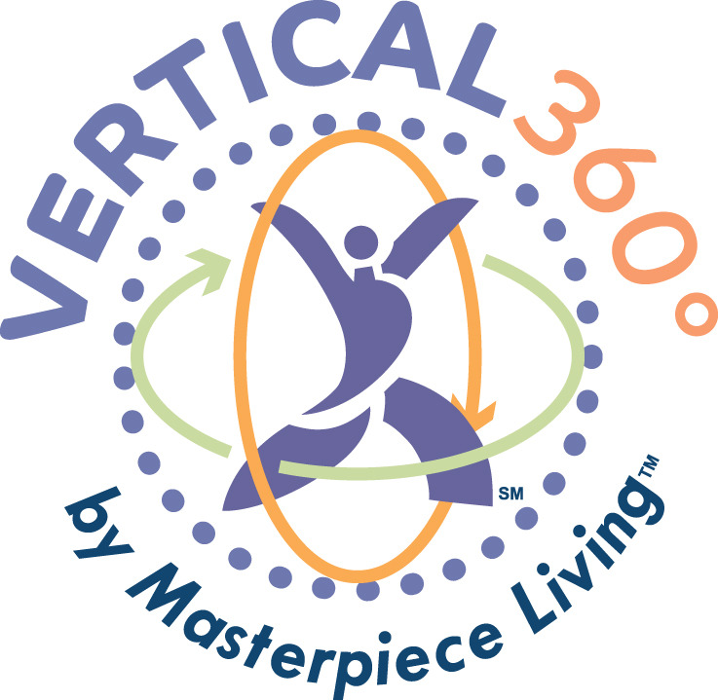  Sign up now!  Vertical 360  Vertical 360 is an interactive, six-session fall prevention program by Masterpiece Living. Vertical 360 reveals how just four key components of lifestyle [social, intellectual, physical and spiritual] can positively impact mobility and fall risk. | Session 1  [insert date/time/location]  ────  Session 2  [insert date/time/location]  ────  Session 3  [insert date/time/location]  ────  Session 4  [insert date/time/location]  ────  Session 5  [insert date/time/location]  ────  Session 6  [insert date/time/location]  Want more information?  Contact:  [insert contact information and when/where/how to sign-up]

