Downloading Zoom on your computer:
Go on your internet browser and search: zoom.us/download
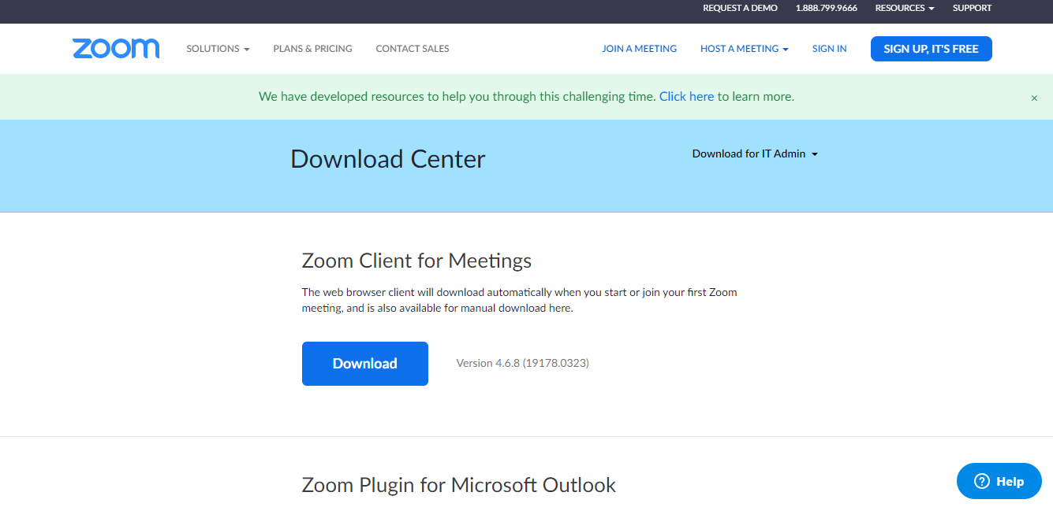
This will be the page that pops up. When you see this screen, press DOWNLOAD (circled above).
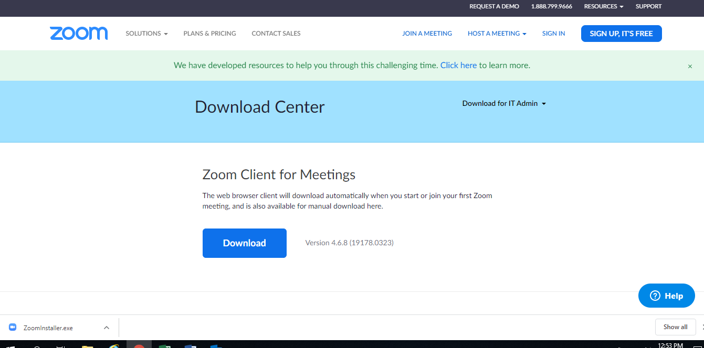
Once you’ve pressed download, “Zoominstaller.exe” will appear on the bottom of your screen (Circled above). Click on this button to open the Zoom Installer.
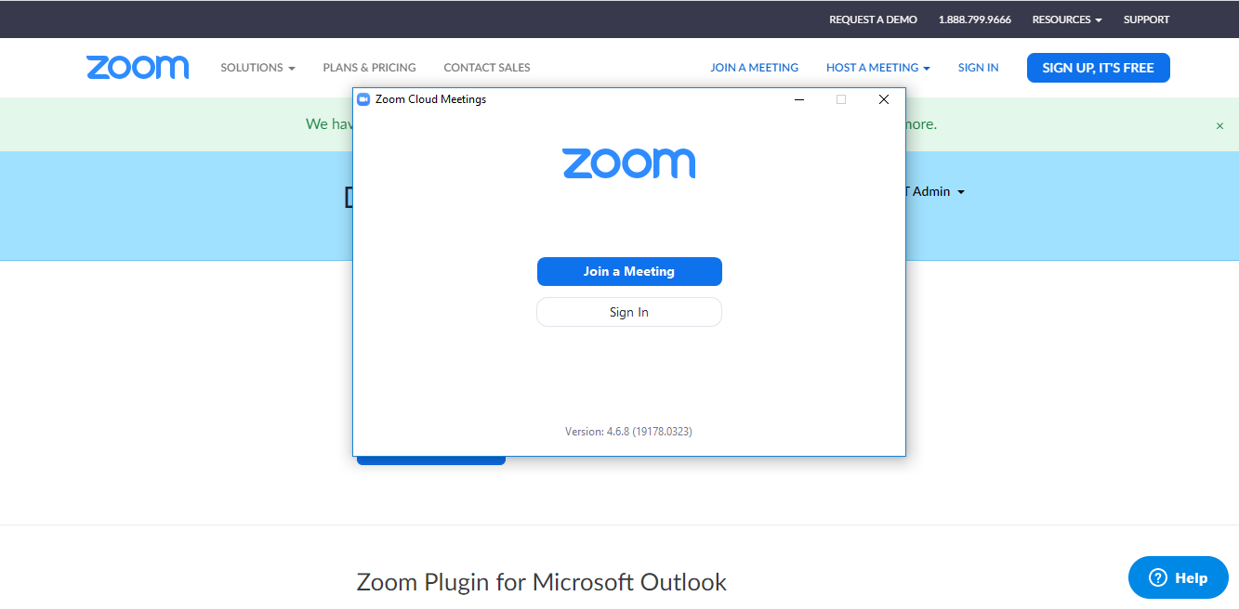
Once you’ve opened the Zoom Installer, the program will install. Once it is installed, the zoom meeting box will appear. This is where you will then click SIGN IN.
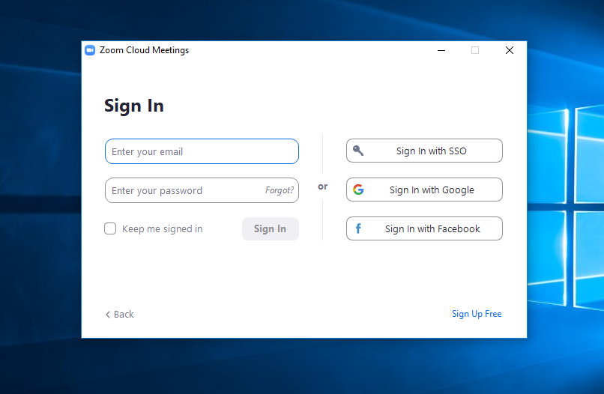
Once you click SIGN IN, it will take you to this page. On this page, you will click SIGN UP FREE in the bottom right-hand corner.

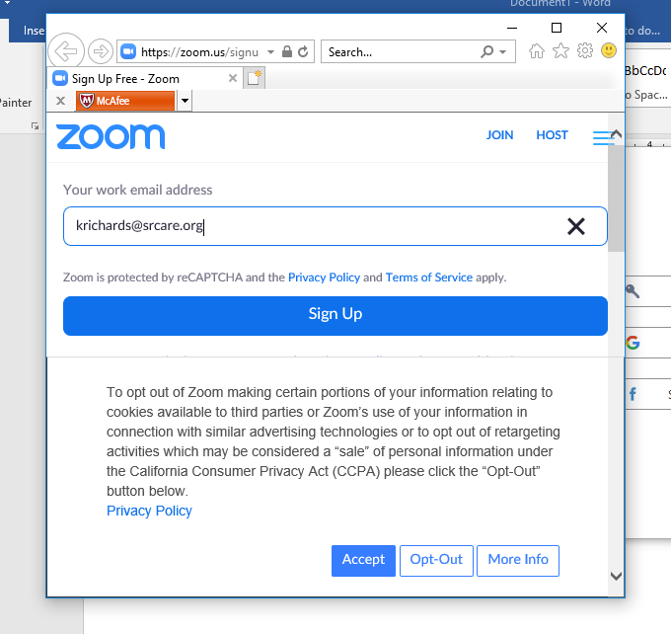
K
Once you’ve clicked SIGN UP, it will take you to this page. You will enter your personal email address where I have entered my work email address, then you will press SIGN UP (Please use the email that has been receiving my emails about support group). You will then press Accept or Opt-out based on your preference.
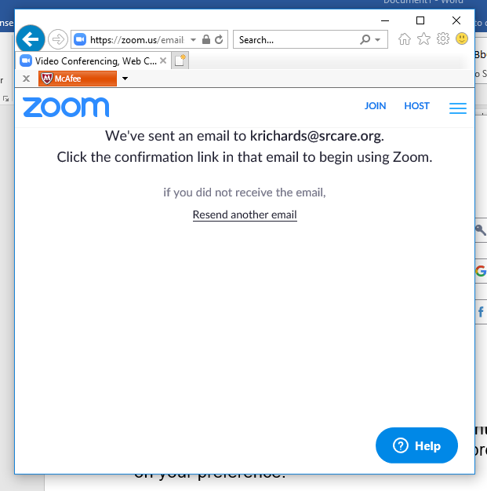
Once you’ve signed up, this screen will pop up. Zoom will send you an email to confirm your email address. Log into your email to look for an email from Zoom.
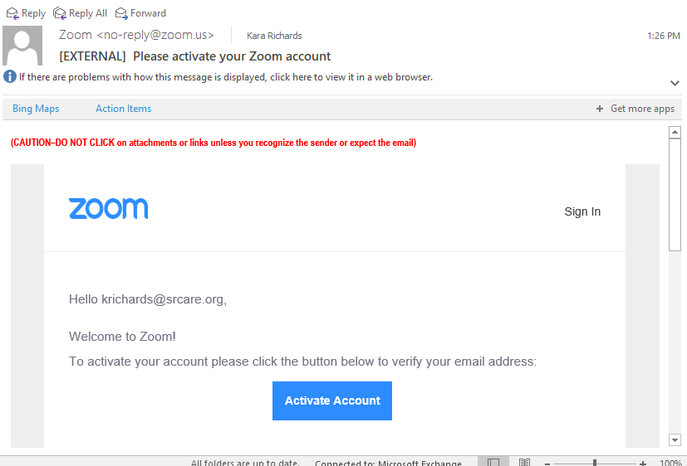
You will then click Activate Account.

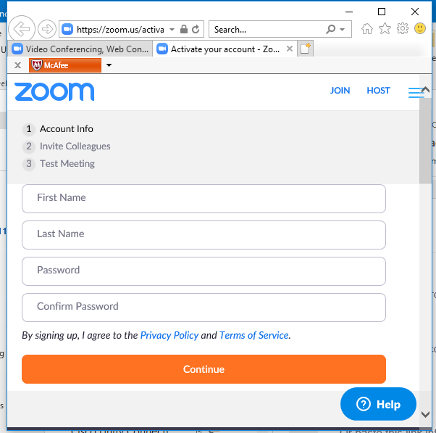
Once you click Activate Account, it will take you to this screen where you can edit your personal information on the account. You will enter your first and last name, and you will create a password. Make sure to follow the guidelines for creating a password (Must have at least 8 characters, at least 1 number, at least 1 letter, and must have both upper and lowercase letters) Once you’ve entered this information, you will then press continue.

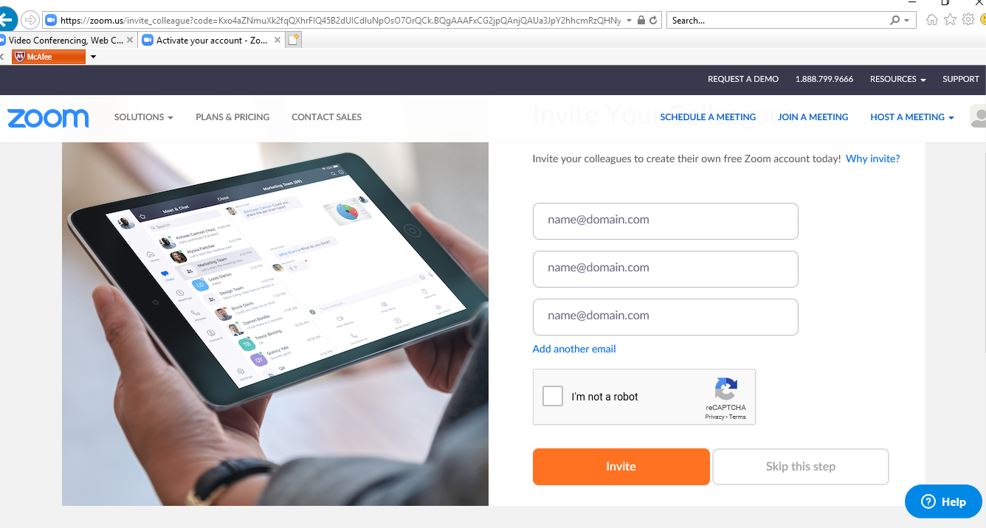
Once you’ve entered your account information, it will take you to this page. On this page, you can either invite your family members to join Zoom (if you know their email address you will put it in the box that says NAME@DOMAIN.COM) or you can press SKIP THIS STEP.

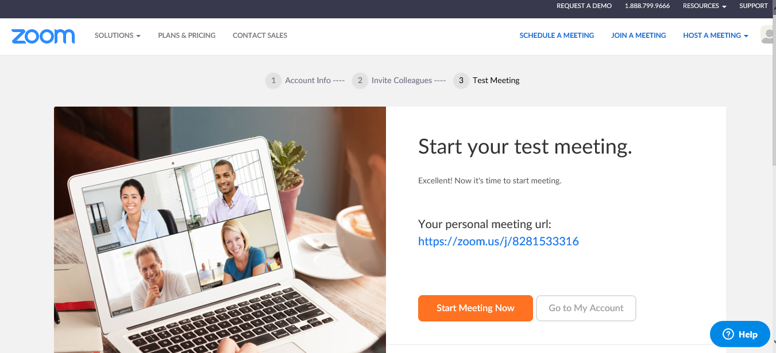
Once you’ve invited your friends or skipped that step, it will take you to this page. You can either start a practice meeting, or click “Go to my account”. You are now ready to take part in Zoom Meetings!

