Collaborative Art Ideas

CD Weaving: http://makeitawonderfullife.blogspot.com/2011/11/cd-weaving-tutorial.html

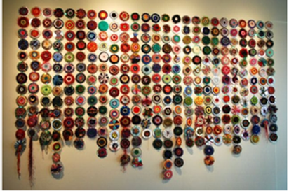
Supplies needed for residents/team Members:
-yarn of all types
-scissors
-old CD’s
Organizer can make plastic needle from plastic lids. See instructions in link.

Paper Crane Mobile: https://www.thesprucecrafts.com/easy-origami-crane-instructions-4082282

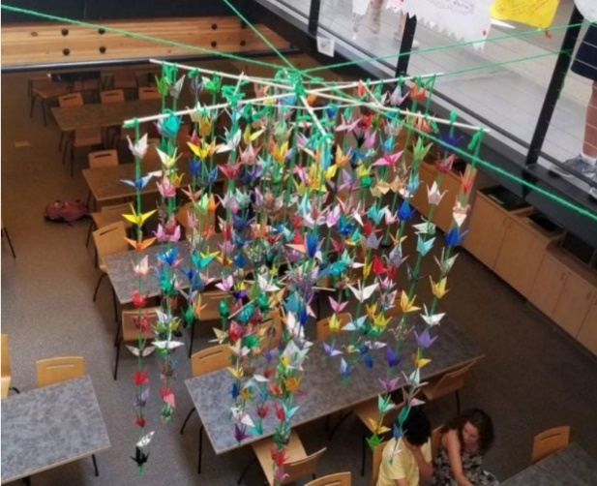
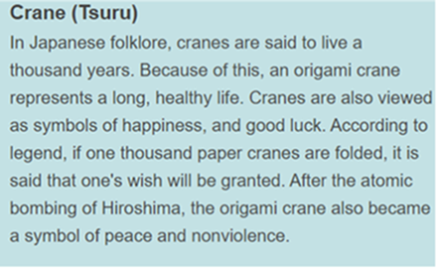
Supplies needed for residents/team members:
- Origami Paper- multi-color or color theme
- Printed folding instructions

Painted Rock Gardens: https://www.ilovepaintedrocks.com/2018/09/50-painted-rocks-that-look-like-cactus-succulents.html

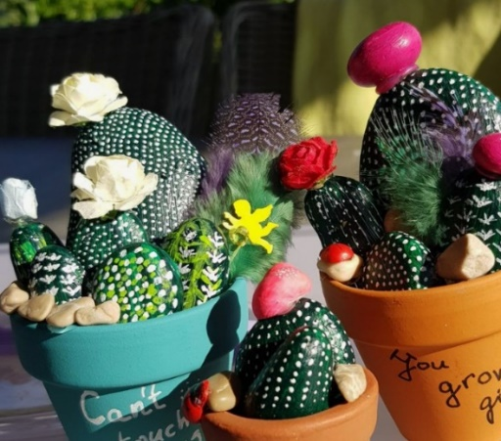
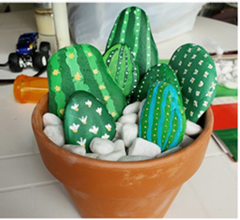
Supplies needed for residents/team members:
- Rocks
- Paint
- Brushes
(Pots, finishing spray and accessories for decorating)
Find more examples on Pinterest.

