We Are the Architects of Our Brains!
By: Dr. Roger Landry, MD, MPH

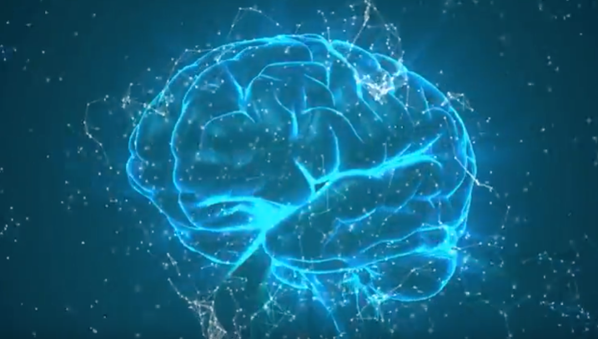
Well, I have some good news for you. Our brains are not the static organs we once thought they were, but are dynamic, alterable, and have the incredible potential for rewiring and healing. Thanks to neurogenesis (the ability to make new neurons) and neuroplasticity (the ability of the brain to reorganize and rebuild new neural pathways as a response to stimulation), we can strengthen our overall brain health by staying physically active and challenging our brains to learn new and complex tasks.

Countless studies have revealed that a combination of aerobic and strength-training exercises, over the course of only six months, can positively impact our memory, even in those beginning to show signs of dementia. We also know that new cells created through neurogenesis can only survive when we incorporate them into new pathways by learning new things. The key to better brain health is a combination of physical exercise and intellectual stimulation. We can, in fact, become architects of our brains!

Live Long. Live Well!

