Never “Act Your Age!”
By: Dr. Roger Landry, MD, MPH

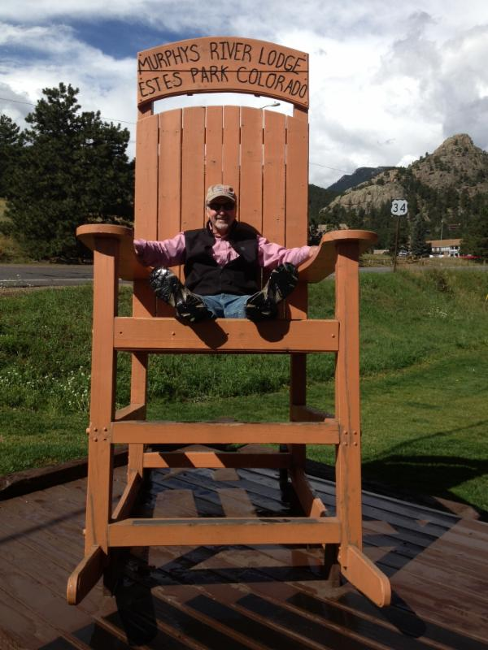
Dr. Ellen Langer, a Harvard University researcher, conducted a now famous study back in the late seventies. Using older men as subjects, she immersed them in an environment from twenty years earlier. Room trappings were from the fifties. Conversation about fifties-era topics was in the present tense. Recorded radio programs were fifties vintage. This immersion resulted in the men acting in ways similar to their twenty-years-younger self: walking more, carrying their own luggage, doing things that had been previously been done for them. The results after only one week were stunning: vision, hearing, cognitive skills all improved. Even the photos of the subjects before and after improved, with subjects looking younger. What were Dr. Langer's conclusions? ... When we are aware - mindful of what we are doing and what expectations we have for ourselves - our bodies will follow; that is, our bodies will attempt to align with those expectations.

To the extent we think of ourselves as more capable, or healthier, or growing, our bodies will attempt to reflect that view. Our bodies reflect our mind. Therefore, if we "act our age," within the context where being old is defined as declining, it's more likely that that is exactly what will happen. However, if we act younger, more optimistic, more confident about what we are capable of, we will indeed continue to grow. The conclusion? Never "act your age!"

Live long. Live well!

