Planning, Promoting, and Facilitating
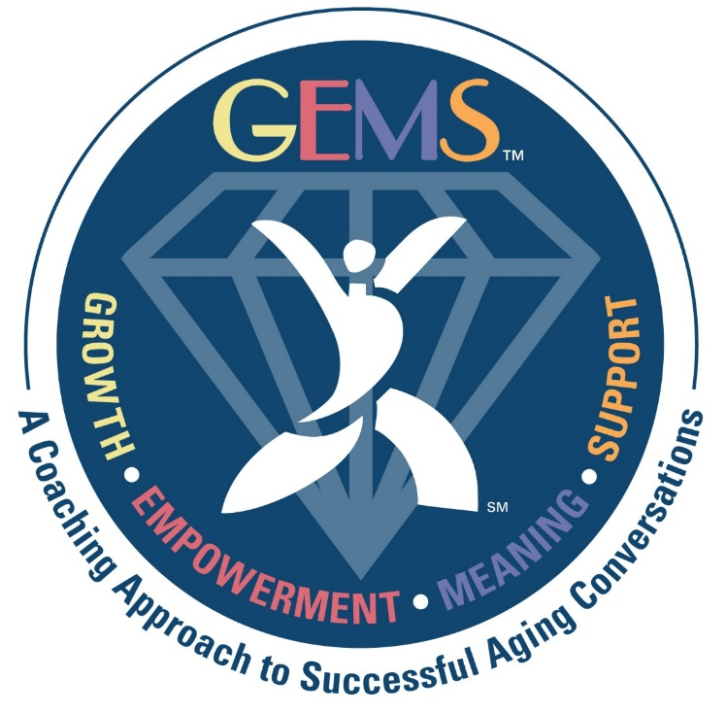
Follow-Up Sessions

Dear Follow-Up Session Facilitators,
Welcome to the comprehensive guide to planning, promoting, and facilitating Masterpiece Living (MPL) follow-up sessions for participants at your organization. The opportunity to reflect on one’s lifestyle choices and identify areas of growth that align with a successful aging lifestyle is the most important step in the MPL process. You have the unique opportunity to support individuals in working toward achieving ongoing growth and potential.
The purpose of follow-up sessions is to celebrate individual strengths and accomplishments, identify desired areas of growth, select action items for supporting areas of growth, and to consider how your organization may support participants in ongoing growth toward achieving their unique fullest potential.
While the concept is simple, implementing change is often difficult. Using resources such as kaizen and coaching language, follow-up session facilitators can successfully meet individuals where they are on their unique journeys and support their efforts in more closely aligning lifestyle choices with what the research clearly demonstrates is most likely to result in a successful aging journey.
This guide is intended to serve as a reference for the Champion Team preparing to offer follow-up sessions. In this guidebook you will find all the tools, tips, and resources necessary for planning, promoting, and facilitating successful follow-up sessions at your organization. For training materials, please review the GEMS MPL Coach Training Videos and supporting documents.
We at MPL appreciate your hard work and dedication to supporting the ongoing growth and successful aging pursuits of every person who is a part of your organization. We welcome your feedback about how we may best continue to support you in this endeavor.

Thank you,
The Masterpiece Living Team

Organizing & Promoting
Objectives
- Complete GEMS: MPL Coach Training
- Organize and promote follow-up sessions for participants
- Prepare for and facilitate effective follow-up sessions

Follow-Up Session Guidelines
Purpose of follow-up sessions
Upon completing the MPL Reviews, participants will receive a feedback report. Follow-up sessions provide an opportunity, in a supportive environment, to reflect upon current lifestyle choices, identify areas of growth and determine action steps for a customized lifestyle plan.
Timing of follow-up sessions
Dr. Robert Kahn, author of Successful Aging and Board Member of Masterpiece Living, recommends follow-up sessions take place within 2 weeks of completion of MPL Reviews.
Recommended size of groups
Masterpiece Living encourages a smaller group of 6-8 in order to facilitate discussion amongst group members while protecting privacy and providing customized support as needed. Research demonstrates stating your intentions out loud in a supportive environment increases your chances of success from 33% to 66%. Additionally, groups create opportunity for participants to develop ongoing support for one another, thus shifting the organizational culture toward one of empowerment.

Individual follow-up sessions
Because the benefits of participating in group follow-up sessions are numerous, Masterpiece Living ideally recommends offering group sessions. However, for those who prefer, you may offer the option for individuals to consult privately with a trained GEMS coach. Individual sessions may be offered as a next step following a group session or in place of a group session.

Length of group follow-up sessions
Masterpiece Living recommends one-hour group follow-up sessions.

Length of Individual follow-up sessions
Setting up a timeframe helps to identify this as a unique interaction. Masterpiece Living recommends 10 minutes for individual follow-up sessions. With the right questions and focused collaboration, this shorter timeframe is effective for meeting the needs of the participant and efficient for the organization. Ten minutes is enough time for a meaningful interaction that empowers participants to find the areas they wish to grow. (Keep in mind that sometimes questions we ask need to sit with the person for some time so they can find their own clarity. You may not be done with a coaching conversation entirely within a 10-minute period, but you can always offer to have an additional coaching conversation at a later time.)

Protection of privacy
Facilitating follow-up sessions is most effective when participants can trust the protection of their privacy. Feedback reports are not intended to support diagnosis or prescription. Information discussed in follow-up sessions should not be shared without permission.

Organizing Follow-Up Sessions
There are a number of ways to assemble groups for follow-up sessions. Masterpiece Living recommends the following considerations:

Invite spouses to participate in separate follow-up sessions
Frequently, spouses get more benefit from participating in separate follow-up sessions. Often, one spouse speaks more than the other or may even be in the habit of speaking on behalf of the other. For a truly empowered and dynamic experience, Masterpiece Living recommends inviting spouses to different follow-up sessions.

Common interests
Sharing common interests is one way to group participants so they enter the group knowing they already have something in common, setting the stage for ongoing social support. Some examples might be people who like to walk, knit, read, or garden. Another consideration of social support may be life circumstance – for example, one MPL community had a high success rate by creating a group of recently widowed women while another grouped individuals who were new to the area.

Cognitive Ability/Higher Levels of Living
Those who may need additional support might benefit from a smaller group and more customized dialogue.

Personality Traits
Personality traits such as introverted, extroverted, talkative, quiet, etc. may be helpful in assembling a balanced group that can complement one another’s strengths.

Scheduling convenience
Offering a variety of times and days to accommodate the schedules of participants.

There are many ways to assemble groups for follow-up sessions. Be creative and do what works for the participants of your organization. Please be aware that Masterpiece Living DOES NOT RECOMMEND grouping participants according to the goals that the facilitator predicts a person may select. The purpose of the group is to discover what they want for themselves and we cannot do that if we have already decided for them.
Promoting Follow-Up Sessions
Once you have determined the time and date of the follow-up sessions, the next step is to invite participants and promote the sessions. Some ideas that have worked well for Masterpiece Living partners include:
- Host a follow-up session campaign to encourage increased participation.
- Flyers are a great way to promote follow-up sessions. Customize the templates Masterpiece Living has created or use following quotes to create your own.
- Customize the Participant Invitation Letter, distribute with feedback reports, Kaizen article and Participant FAQs or create a personalized invitation.
- Be prepared to answer participants’ frequently asked questions.

Participant FAQs
What is the benefit of participating in a follow-up session, as opposed to reading the feedback report myself?
This is an important opportunity to reflect on what you have learned through taking the Masterpiece Living Reviews and put insight into action. By exploring what’s next in a supportive environment you are completing the most valuable part of the Masterpiece Living process – comparing your current lifestyle choices to that which the research tells us is most likely to result in a successful aging journey, then identifying areas of growth on your own successful aging journey to continue building resilience in the four components.

What is the benefit of participating in a group follow-up session, as opposed to individual?
Research demonstrates sharing your intentions with others in a supportive environment increases your chances of success from 33% to 66%. To quote Dr. Gobble, "Declaring intentions and seeking support for new behaviors is critical for successful behavior change. As the old saying goes, ‘no person is an island,’ and almost no one succeeds in reshaping their lifestyle alone. So seek out support and share your journey of change with those who care about your success. "
What can I expect from participating in a follow-up session?
Now that you have completed the MPL reviews, it’s an opportunity to look at your current lifestyle choices and decide what’s next for your successful aging journey.

Do I have to share my successful aging score or other information from the feedback report in the group?
No, in fact, the focus of the group is to support you in exploring what you want for yourself going forward. The feedback report is simply a guide to prompt you in reflecting on possible areas of growth you may not have considered otherwise.
I’ve made it this far and I’m happy with my previous successes. Why would I set a goal for myself?
It’s all about what you want for yourself today. As Dr. Roger Landry says, “It’s not so much when or whether we achieve a particular goal, it’s the trying that is beneficial. Attempting to learn new things, increase strength, be more socially engaged, or uncover a sense of purpose have all been shown to decrease risk and increase resilience resulting in less impairment and loss of independence.”
What will you do with the information I share in a group follow-up session?
At the beginning of the group we ask that participants agree to respect the privacy and confidentiality of the group by not sharing anything that was discussed outside of the group and we do not use your information for anything other than supporting you on your personal successful aging journey.

Follow-Up Sessions
Group Follow-Up Sessions
Objectives
- Reflect on current lifestyle choices and how that compares to what the research tells us is most likely to result in a successful aging journey
- Identify area(s) of growth and determine kaizen action steps.
- Consider how the organization may support the participants in their identified areas of growth

Before Session
- Set up room in a way that allows for discussion and makes it easy for everyone to see and hear one another as well as write on their worksheet.
- Print the following materials:
  - Facilitator Agenda
  - Participant Agenda
  - Area of Growth Worksheets

During Session
The facilitator agenda is designed to guide the conversation and ensure a meaningful experience for participants. In general, the follow-up session will include:
- Welcome & Introductions
- Brief clarification about Masterpiece Living Feedback Reports
- Identifying Areas of Growth & Action Items
- Community Support of Goals
- Next Steps & Takeaways
After Session
- Reflect
  - What worked well?
  - What might you do differently next time?
  - Where do might you benefit from additional support, resources, or clarification?
- Debrief with your Partnership Specialist.

- Complete action items discussed with participants regarding the ways in which the organization may better support their successful aging journeys.

Ongoing Follow-Up Support
Individual Follow-Up Sessions
Individual Follow-Up Sessions may be appropriate for some individuals as ongoing support beyond the initial group Follow-Up Sessions. Some examples may be individuals who are extremely shy or introverted, those facing complex or very new challenges, and those who have limited sense of self-efficacy.
Ongoing Follow-Up Groups
Some organizations have had success in hosting regularly occurring follow-up groups that offer peer support in continuous growth for identified areas. Option to use this On-going Follow-up Sessions Facilitator Guide.
Common Interest Groups
During a Follow-Up Session, participants may find others who share similar interests in growth opportunities. Masterpiece Living encourages the creation of small groups that meet regularly based on similar areas of growth. These groups are frequently resident led.

Resilience Program by Masterpiece Living
Resilience is 10-session intellectual, physical, spiritual and social exploration by Masterpiece Living that revisits concepts introduced in Dr. Roger Landry’s dynamic book, Live Long, Die Short: A Guide to Authentic Health and Successful Aging. Resilience expands upon Dr. Roger’s Ten Tips for Aging Successfully and offers participants the opportunity to chart a course for their Personal Lifestyle Plan through meaningful activities and discussion.

