Living It Campaign
invitation from Leadership

Dear Residents, Team Members and Family Members at [Community name],
I am excited to invite you to participate with me in Living It, a campaign powered by Masterpiece. Living It will run from [date your community is running campaign]!
Living It is a four-week campaign aimed at challenging and inspiring us to try new pursuits in the four pillars of healthy longevity (Social, Intellectual, Physical and Peace and Fulfillment). Focusing on one pillar per week, participants are encouraged to try four new activities each week. As we age, our brains are able to make new connections as we learn and try new things. Our goal is to inspire continued growth by trying new things not only during this campaign, but throughout the year.
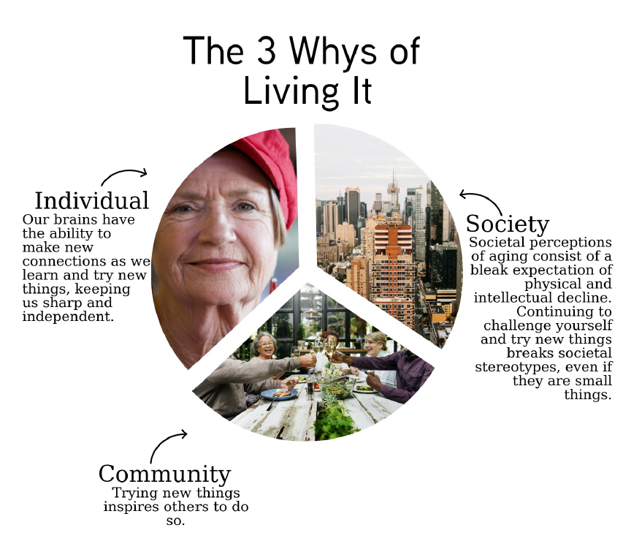
A Living It Challenges document will be used to track the number of new things we try. The list contains [four items under each of the four pillars, for a total of 16 new challenges]. When you try new things, mark them off the list or complete items of your own choosing. At the end of the campaign, your Living It Challenges document can be turned into [person/place where lists will be turned into]. There will also be the opportunity to win [insert drawings/awards that will be offered at the end of Living It - OPTIONAL].
You can sign-up to participate by [insert instructions here].
Join us for the kickoff celebration on [share date here]!
I am looking forward to participating in this campaign with you,
[Executive Director]

