longevity in action

newsletter article

Build your “whole person” strength by fostering resilience!
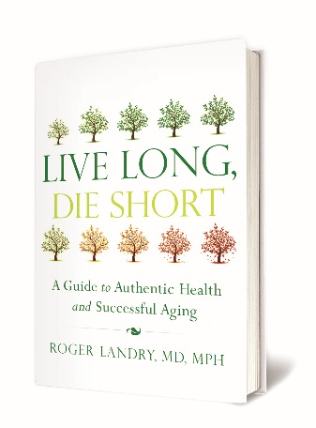
Life presents challenges, change, and ‘bumps in the road,’ no matter how hard we may try to avoid them. Join us for Longevity in Action powered by Masterpiece to build upon your ability to quickly adapt to changes as they occur. Resilience is what allows us to bounce back after physically, mentally, and emotionally stressful situations in order to live healthier, happier, and more fulfilling lives.

You’ll explore science-backed concepts introduced in Dr. Roger Landry’s book, Live Long, Die Short: A Guide to Authentic Health and Successful Aging. Learn from your peers through group discussions and interactive events while taking time to personally reflect on your own experience. Sign up today to increase your ability to bounce back after life’s curve balls!
For some, this may be a new experience. For others, this can provide a tool to support your current lifestyle choices. Wherever you are on your journey, join us!
[Insert Date & Time of Resilience at your community Here].

