longevity in action
Keep moving

Facilitator Preparation (What You’ll Need)
- Keep Moving worksheets
- Writing utensils
- A copy of Dr. Roger Landry’s Live Long, Die Short: A Guide to Authentic Health and Successful Aging (optional)
- Comfortable walking shoes or sneakers; Water to stay hydrated (participant’s responsibility)*
Materials for Option 1: Moving to Music*
- A way to play three different songs (e.g. streaming service, videos, or portable sound system)
- Song suggestions: An up-tempo Standard from the 20s, 30s or 40s; A slow, melodic instrumental or world music; A modern “feel good” pop song; David Dworkin’s Conductorcise videos (https://bit.ly/34Pw0ir)
Materials for Option 2: Movement Challenge*
- Stopwatch
- Straight back chair with no arms
- Tape measure
- Masking tape
- Movement and Motion Instruction Booklet

(Note: Facilitators who are including one or both optional events may also choose to begin with the event(s) and return to the day’s reading afterward.)

Session Content:
Please read this aloud:
A few reminders before we begin …
- Please be respectful to one another. Everyone in this room comes from a different background that has formulated who they are as a person and contributed to their unique opinions. As a group, we will observe respect as a guiding principle as we interact with one another. It is our goal that all participants feel valued, respected, and heard.
- Share without imposing your beliefs on others. Please refrain from convincing others to adopt your opinions.
- Keep an open mind. Our discussions will be thought-provoking and insightful. You may not agree with everything you hear, but please be willing to consider opinions that may be different from your own.

Today’s Objectives:
Please share these objectives with participants.
- To explore how we move daily and how often.
- To discuss the benefits of movement.
- To determine what simple changes we can make to make movement a regular part of our daily lives.

Opening Passages: Keep Moving and Dorothy Dares
Read this excerpt from Live Long, Die Short aloud: Pages 87.

What would you be willing to do to get the following outcomes: reduce the likelihood that you will be afflicted with heart disease, or stroke, or cancer, or diabetes, or dementia, or osteoporosis; reduce the likelihood that you will fall, and if you do fall, reduce the likelihood that you would break a bone; feel better; look better; and overall have more energy to enjoy life more? Sound good? Would you be willing to move? Yes, just moving, for thirty to forty-five minutes most days, in order to reap these benefits? You’re thinking there’s got to be catch; there’s something I’m not telling you, right? How and why can so many good things come from just moving?

Read this excerpt from Live Long, Die Short aloud: Pages 95
Dorothy was in her seventies and had led a full life. She had retired after working in a medical office for decades, and enjoyed living in her home and adapting to her new life as a retired person. But now, after a decade of retirement, she knew she was in trouble. She had severe knee pain, had gained weight, and now had diabetes. She also knew that she had become more isolated over her decade of retirement. So she dared.
She dared to move from her home of so many years into a retirement community. She did it to become more engaged with other people. She chose one that had Masterpiece Living and that offered her both the opportunity to evaluate her current lifestyle and the support to make the changes she chose to make. When she saw her Lifestyle Inventory feedback report, she was not surprised. She had little social engagement, was stag- nant intellectually, and was doing little to nourish her inner self. But she knew immediately what she needed to attend to first. She had to address her physical self first.
She began modestly with water aerobics at 5:30 a.m. and met some marvelously animated people who were unafraid to put a bathing suit on again. She began walking regularly and soon found others who enjoyed walking and talking. She joined groups with the community and filled her day with social activity and more and more movement. She was much happier—and along the way, during that first year in her new life, some other things happened. She lost seventy pounds and returned to her high school weight. Her doctor told her she no longer had diabetes. And her knee no longer hurt! She was active, engaged, and fulfilled. She felt empowered, with a new lease on life, and she dared more. She dared to take up the flute again after forty years. She dared to start a small musical group that actually played in public! Dorothy dared to move, and it made all the difference.
(Optional: Here is a short video link to Dorothy’s story: https://bit.ly/3aSr1Sg.)

Group Discussion
Please read this aloud:

As we take a few minutes to discuss this passage, keep in mind that we need movement for all our bodies’ systems to work properly. This comes from a species-specific need we inherited from our hunter-gatherer ancestors.

(If necessary, please remind participants to be respectful by limiting answers to about a minute so that more people have time to share.)

Question: Have you ever experienced an injury that required movement to recover?

Question: What was that experience like?

Group Activity Option #1: Moving to Music
(Note to Facilitator: Please remember to keep the needs of each participant in mind for this event. If necessary, provide safety guidelines and modifications (e.g. stressing environmental awareness for potential “slip and trip” obstacles or having someone with compromised balance maintain one hand on the back of a sturdy chair if needed).

Please read aloud:
Let’s get moving! We’re going to play a few songs of varied tempos. You are welcome to stand and move to the music or “chair” dance. Forget about “how” to dance and instead look for different ways to move your hands and feet and swing your arms. Don’t forget to lift your legs in the air or bend your knees. How many different ways can you move? Allow yourself to be in the moment. As a reminder, it’s important to stay hydrated. Feel free to stop if you need a drink of water or to catch your breath.

Group Activity Option #2: Movement Challenge
(Note to Facilitator: Exercises include the 30-Second Chair Stand, Single Leg Balance, and the Two-Minute March. These are good exercises for people of all ages! Have participants record their results on their worksheet.)

Please read aloud:
Movement is essential to support your independence and resilience. Movement affects everything, from circulation to metabolism to immunity. Your body and mind benefit from strength, flexibility, balance, endurance, and agility. When done with regularity, it offers a pathway to actualize (reach) your potential.
Today we’re going to do a few exercises from Masterpiece’s Movement Challenge. This may be new to some of you, or you may have completed these exercises previously. Even if you’ve participated in these exercises before, you can take this opportunity as a check in to see how your results today compare to a review you did before. After each exercise, we’ll take a moment so that everyone can record their results on their worksheet.
(Note to facilitator: Review the focus and benefits of each exercise as a group. If it’s helpful, you may want to enlist the help of a model to demonstrate each exercise before you attempt them as a group. If doing as a group, you will need to time each exercise with a clear “start” and “stop” using a stopwatch.. For the “single-leg balance” exercise, you may want to call out the seconds (i.e., “10, 11,12”) so that participants who are unable to complete the full 20 seconds can record their results. As an alternative, you may choose to work one-on-one with participants.)
- 30- Second Chair Stand
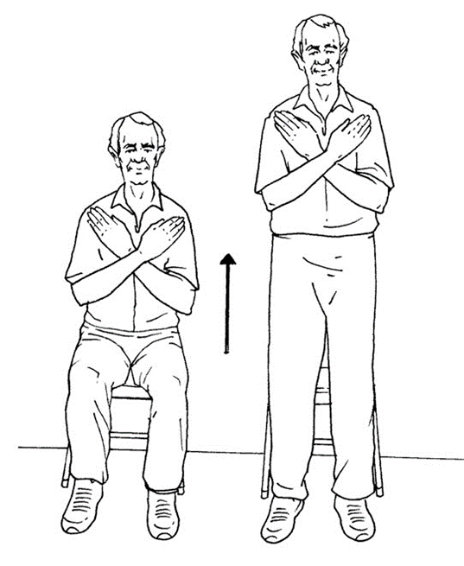
Primary focus: Lower body strength and core stability.
Why it is important: Completing this exercise on a regular basis can increase your lower body strength as well as cardiovascular strength. Lower body strength is important for getting out of a chair or car and standing from a kneeling position.
Steps to complete this exercise:
Equipment needed: Chair (place against a wall) and a timer.
- Starting in a fully seated position with your arms crossed against your chest (optional), stand up and sit back down without using the arm rests, if possible.
- Count the number of times you stood to a full standing position and returned to a fully seated position in 30 seconds. If you are on your way up to stand when time is called, you will be given credit for that stand.
- Practice the movement.
- Go!
- Participants record number of repetitions.

- Single-Leg Balance Test​
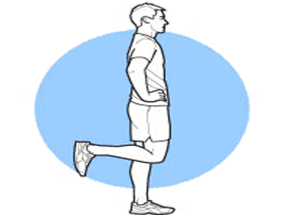
Primary focus: Static balance and proprioception (awareness of position and movement of the body).
Why it is important: This is an effective exercise for improving balance and decreasing fall risk. Working up to 20 seconds on each leg will also strengthens your brain and functional ability.
Steps to complete this exercise:
Equipment needed: Chair and a timer
- Place chair in front of you so you can use the back of chair if you start to lose your balance.
- Stand on one foot as long as possible, you can have your arms out to the side for balance. Repeat with the other foot.
- Practice.
- Go!
- Participants enter number of seconds for left leg and right leg.
- 2-minute March​
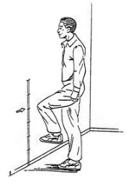
Primary focus: Aerobic endurance​
Why it is important: Practicing this movement more often can improve the aerobic strength of your heart. Endurance supports the activities you enjoy; shopping, visiting places, walking for a distance, and traveling.
Steps to complete this exercise:
Equipment needed: timer
- March in place for two minutes counting the number of times the right knee is raised.
- Practice the movement.
- Go!
- Participants record number of repetitions.

Group Discussion About Group Movement Event
(If necessary, please remind participants to be respectful by limiting answers to about a minute so that more people have time to share.)

- Question: How do you feel? (e.g., energized, tired, accomplished etc.,)
- Question: What did you think of this experience? Was there anything that surprised you?

- Question: Why is movement, from day-to-day activities to strength-building exercises and stretching, so important to a resilient lifestyle?

- Question: What are some simple ways to add more movement in our daily activities?

Wrapping Up Today’s Session
Please read this aloud:

Thank you, everyone, for being here to share your time and your thoughts with each other. We look forward to many more insightful opportunities and discussions from Live Long, Die Short about building resilience. As a reminder, our next session is scheduled for [Day – Date – Time – Location]. Our topic is [Topic Name]. You are welcome and encouraged to bring a friend, but please RSVP for both of you. The sign-up sheet is located [Location]. Additionally, if you would like to assist with facilitating next week’s session or a future session, please let me know.
Before you go, please take a few minutes to write down a brief journal entry about today’s session. It can be anything from notes you’d like to remember or a personal initiative you might like to take. Before each entry, you’ll notice a couple of questions to think about, and you’ll have the opportunity to sum up this session in a simple word or phrase. Your journal is for your eyes only. Remember, I am always available to help answer any additional questions you may have about this journey.

* These materials are for OPTIONAL events

