neurobics

Stages of Memory

Trail-Making Activity

  - Name: Date: Time to Complete:
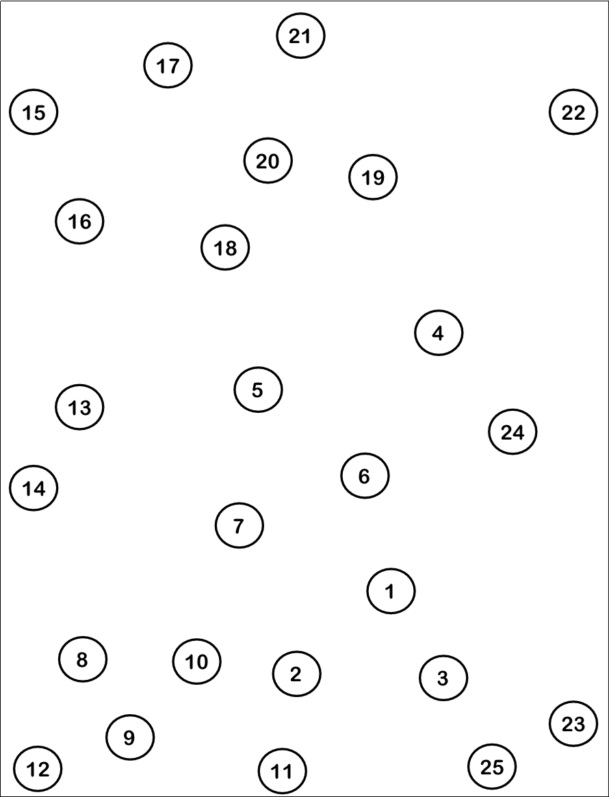

neurobics

Stages of Memory

Letter Symbol Activity: Explanation
Letter symbol activities exercise attention, concentration, and visual search. These abilities fall under the broad category of cognitive functions called executive functions. As the term implies, executive functions control and manage other cognitive skills. You might think of executive function as the “control center.” Improved executive function can affect many daily activities—from organizing tasks, to prioritizing, managing time and decision-making. In addition, improved visual search abilities (which are exercised in letter symbol activities) can be useful in driving or walking through environments with potential trip hazards.
The letter symbol activity is similar to the widely used Symbol Digit Modalities Test (SDMT), which is used to identify deficits in executive functioning. The SDMT involves a simple substitution task. Using a reference key, the examinee has 90 seconds to pair specific numbers with given geometric figures. The letter symbol activity is also a substitution exercise, except that letters are used instead of numbers. When the letters and symbols are matched up, a phrase or quote is revealed. Letter symbol activities exercise the prefrontal area of the brain.
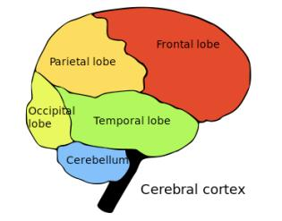

neurobics

Stages of Memory

Letter Symbols Activity
In this activity, use the key to decode the famous quote. For example, a heart is a code for “T”. After figuring out all letters, you will be able to read the quote.
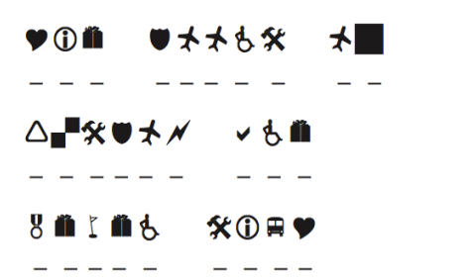-Benjamin Franklin
KEY:
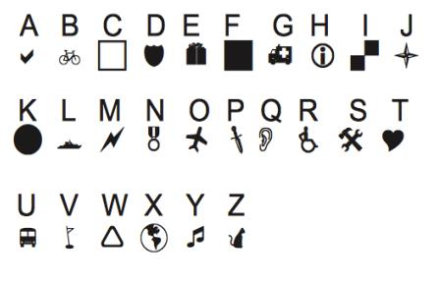
Answer: “The doors of wisdom are never shut.” -Benjamin Franklin

neurobics

Stages of Memory

State Activity

- Florida starts with two consonants. Name another state that starts with two consonants.

Answer: ________________________________________

- The name of one state is made of two common words which are separated by one letter. The two common words are actually antonyms (or opposites). Which state is it?

Answer: ________________________________________

- If you drop the first and last letters from “Nevada”, you’re left with the common first name DAVE, spelled backward. What state, without its first and last letters, is a popular actor’s last name, spelled backward (hint: Star Trek)?

Answer: ________________________________________

- Two different words meaning “employ” are hidden in the names of two states. Which states?

Answers: ________________________________________

- Which state ends with a five-letter woman’s name? Which state has a man’s nickname spelled backward inside a woman’s name?

Answers: ________________________________________

Answers: a. Rhode Island b. Connecticut (connect and cut) c. Wyoming, Nimoy (Leonard Nimoy, Mr. Spock of “Star Trek”), d. Massachusetts (use) and New Hampshire (hire), e. Indiana (Diana); Montana (Nat spelled backward inside Mona)

neurobics

Stages of Memory

State Activity

- Anagrammatically speaking, the names of seven states are hidden in these word groups. Rearrange the letters to find them.
Ah! Look ma. ___________________________________________
I own gym. ___________________________________________
Men share whip. ___________________________________________
Loan torn chair. ___________________________________________
Horned dials. ___________________________________________
Coins wins. ___________________________________________
Show inn tag. ___________________________________________
- Name the four states that start and end with the same letter.
a. ____________________________________________________
b. ____________________________________________________
c. ____________________________________________________
d. ____________________________________________________
Answers: 1. Oklahoma, Wyoming, New Hampshire, North Carolina, Rhode Island, Wisconsin, Washington
2. Ohio, Alaska, Alabama, Arizona

