NEUROBICS
Dementia

Antonyms Activity #1
Antonyms are words that mean the opposite of the other. In this activity, try to think of a word (or words) that have opposite meanings. The more difficult ones are challenging for most people and may be appropriate to do in a group setting. Many of the given words have multiple antonyms, so there may not be only one correct answer.

Write in the word that is the opposite of the word listed:
(Example: Big – Small)

- Up - _______________________________
- Hot - _______________________________
- Winter - _______________________________
- White - _______________________________
- On - _______________________________
- Over - _______________________________
- Loud - _______________________________
- Easy - _______________________________
- Left - _______________________________

Answers: 1. Down 2..Cold 3. Summer 4. Black 5. Off 6. Under 7. Soft 8. Difficult 9. Right

NEUROBICS
Dementia

Antonyms Activity #2
Antonyms are words that mean the opposite of the other. In this activity, try to think of a word (or words) that have opposite meanings. The more difficult ones are challenging for most people and may be appropriate to do in a group setting. Many of the given words have multiple antonyms, so there may not be only one correct answer. Write in the word that is the opposite of the word listed:
(Example: Big – Small)
- Indoor – _______________________________
- Apart – _______________________________
- Exhale – _______________________________
- Improve – _______________________________
- Ascend – _______________________________
- Civilian – _______________________________
- Confident – _______________________________
- Alone – _______________________________
- Amuse – _______________________________
- Broad – _______________________________
Answers: 1. Outdoor 2. Together 3. Inhale 4. Worsen 5. Descend 6. Military 7. Insecure 8. Together 9. Bore 10. Narrow

NEUROBICS
Dementia

Sudoku Activity #1
Fill in the blank squares so that each row, each column and each 2-by-2 block contains all the digits 1 through 4.
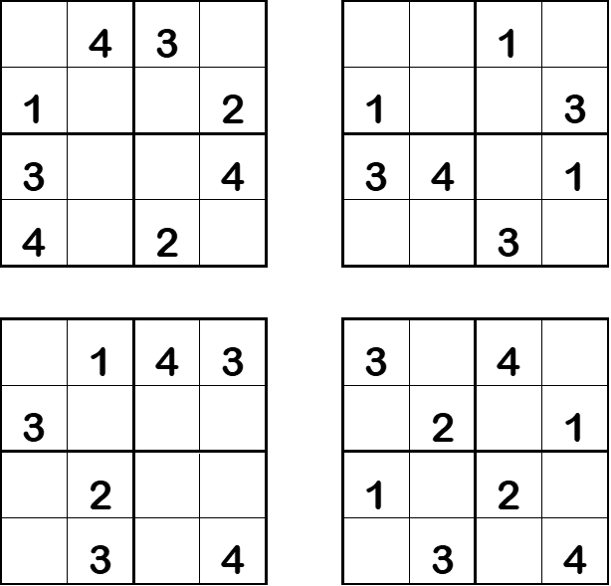

Sudoku Activity #1: SOLUTIONS
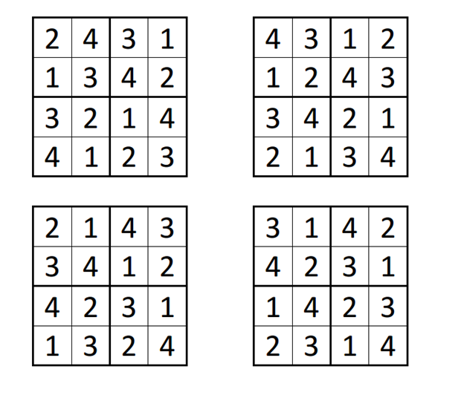

NEUROBICS
Dementia

Sudoku Activity #2

Fill in the blank squares so that each row, each column and each 3-by-3 block contain all of the digits 1 through 9. If you use logic you can solve the puzzle without guesswork.

5 |  |  |  | 4 |  | 6 | 9 | 7
8 |  |  |  |  | 2 |  | 4
 |  | 9 | 5 |  | 3 | 1 |  | 8
 |  | 1 | 4 | 3 |  |  | 7
 |  |  | 7 |  | 9
 | 7 |  |  | 6 | 5 | 4
1 |  | 3 | 2 |  | 4 | 7
 | 2 |  | 9 |  |  |  |  | 4
6 | 9 | 4 |  | 1 |  |  |  | 5

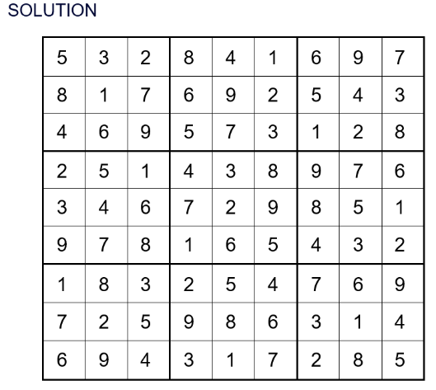

NEUROBICS
Dementia

Walking Log

Day | Date | Duration | Notes
Sunday
Monday
Tuesday
Wednesday
Thursday
Friday
Saturday

