NEUROBICS
Memory Strategies

Animal Activity: Alphabetic Cueing Part 1
Letter | Round 1 | Round 2
A
B
C
D
E
F
G
H
I
J
K
L
M

NEUROBICS
Memory Strategies

Animal Activity: Alphabetic Cueing Part 2
Letter | Round 1 | Round 2
N
O
P
Q
R
S
T
U
V
W
X
Y
Z

NEUROBICS
Memory Strategies

Homonyms Activity
Homonyms are words that sound the same but are spelled differently and have different meanings. For example, hair and hare are homonyms. Try to generate the homonym for each word listed below.

- Beet |  |  | 10. One
- Hoarse |  |  | 11. They’re
- Prince |  |  | 12. Bored
- Plain |  |  | 13. You
- Foul |  |  | 14. For
- Pale |  |  | 15. Cruise
- Nose |  |  | 16. Flower
- Sent |  |  | 17. Hi
- Whale

Answers: 1. Beat 2. Horse 3. Prints 4. Plane 5. Fowl 6. Pail 7. Knows 8. Scent 9. Wail 10. Won 11. There 12. Board 13. Ewe 14. Four 15. Crews16. Flour 17. High

NEUROBICS
Memory Strategies

Making a List, Checking It Twice
Objective: To practice categorizing information to create less strain on one’s memory and decrease the experience of forgetting. Study the following list for approximately one minute:

Party | Sudoku | Reading
Dance | Bingo | Computers
Singing | Walking | Gardening
Yoga | Tai chi | Meditation
Crossword puzzles | Art | Aerobics

NEUROBICS
Memories Strategies

Homonyms Crossword Puzzle
Find the words that have the same sound as the clue but are spelled differently.
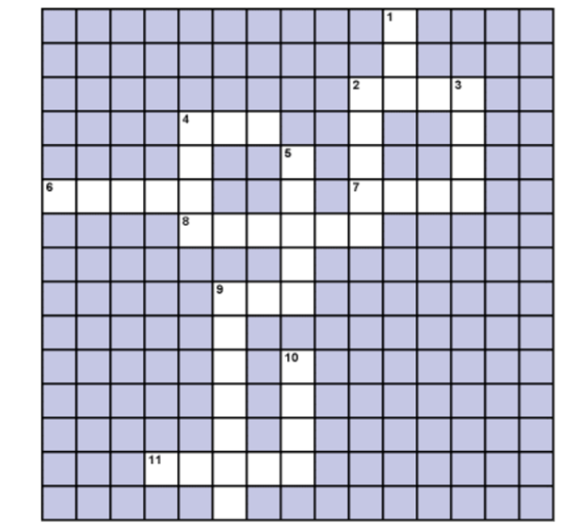
Across | Down
2. red | 1. sea
4. by | 2. right
6. clothes | 3. dear
7. our | 4. blue
8. wait | 5. knight
9. aunt | 9. aloud
11. there | 10. for
Answers: Across: 2. Read 4. Buy 6. Close 7. Hour 8. Weight 9. Ant 11. Their
Down: 1. See 2. Right 3. Deer 4. Blew 5. Night 9. Allowed 10. Four

