neurobics

Review

Trail-Making Activity
Name: Date: Time to Complete:
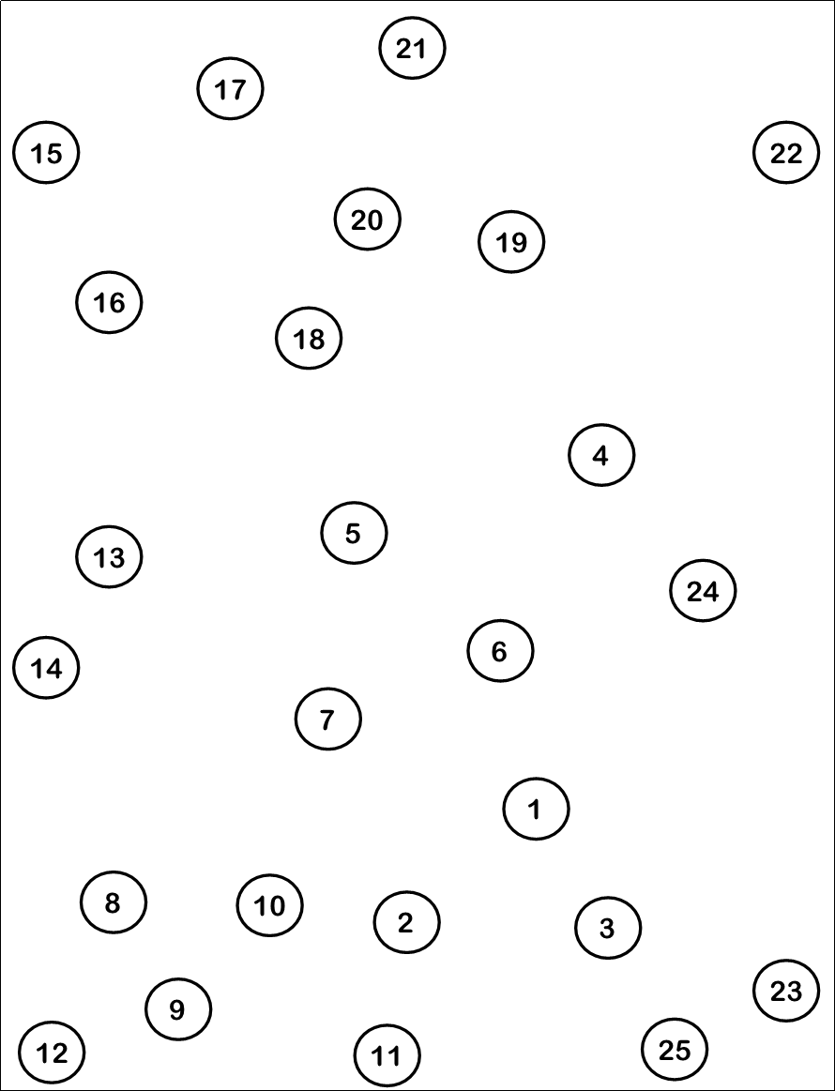

neurobics

Review

Stroop Activity
The Stroop Effect can be seen when people take longer to state the color of ink used to print words that spell out incongruent colors rather than congruent colors (this is easier to experience in person than understand in written text).
- Why does the Stroop Effect occur and what does it have to do with memory?
Older adults experience something similar to the Stroop Effect when they have difficulty inhibiting automatic or procedural behaviors. This can negatively affect memory ability. Therefore, exercising this ability may help one's memory ability.
- Why is it more difficult to read the color of the ink when that color doesn’t match the color that is spelled?
The difficulty occurs because reading is an automatic behavior. The act of reading the word must be inhibited; however, as we get older, we often develop a slightly decreased ability to inhibit some behaviors, and this can negatively affect one’s ability to make new memories. When making new memories, we need to inhibit attention towards irrelevant stimuli or thoughts and attend to the to-be-remembered material.

Stroop #1

1 2 3 4

Stroop #2

1 2 3 4

neurobics

Review

Split Words Activity
This activity is designed to exercise the frontal lobes of the brain by exercising attention and concentration. This activity also requires use of visual memory (occipital lobes) and word recognition (temporal lobe). Draw a line from the letters on the right to the letters on the left to complete the word. HINT: These are all fruits.

CHE APE

BAN NGE

AP APPLE

PE AYA

GR PLE

PINE GO

BE RRY

ORA ACH

MAN ANA

PAP RRY
Answers: Cherry – Banana – Apple – Peach – Grape – Pineapple – Berry – Orange – Mango – Papaya

neurobics

Review

Brainwork Activity: Einstein’s Puzzle
There are five houses in five different colors. In each house lives a person of a different nationality. The five people drink a certain type of beverage, smoke a certain brand of cigar and keep a certain pet. Using the clues below, can you determine who owns the fish?
- The Brit lives in a red house.
- The Swede keeps dogs as pets.
- The Dane drinks tea.
- The green house is located to the immediate left of the white house.
- The green house’s owner drinks coffee.
- The person who smokes Pall Mall cigars raises birds.
- The owner of the yellow house smokes Dunhill cigars.
- The person living in the house right in the middle drinks milk.
- The Norwegian lives in the first house.
- The person who smokes Blend cigars lives next door to the one who keeps cats.
- The person who keeps horses lives next door to the person who smokes Dunhill cigars.
- The owner who smokes Blue Master cigars drinks beer.
- The German smokes Prince cigars.
- The Norwegian lives next door to the blue house.
- The person who smokes Blend cigars has a neighbor who drinks water.

neurobics

Review

Brainwork Activity: Take It From There
Place the three-letter groups in the empty squares before and after the given letters to complete nine-letter words. Words are read left to right only. When the diagram is filled correctly, the two columns of letters under the arrows will spell out related words.

BUN | NAT |  |  |  | K | H | O
CEL | NCE |  |  |  | A | R | A
CLE | NCY |  |  |  | N | A | L
DED | PEN |  |  |  | E | S | T
FLI | PIG |  |  |  | P | P | A
FUL | PLE |  |  |  | H | E | A
IAL | SIG |  |  |  | N | T | I
LLY | ULA |  |  |  | I | N | S
MEN | USE |  |  |  | U | R | A

Answers: Bunkhouse, Clearance, Signalmen, Celestial, Flippancy, Pigheaded, Plentiful, Peninsula, Naturally

RELATED WORDS: negligent, unmindful

