fending off falls

Preventing falls by moving more

Date: _____________________

Summary:
In the first session, we reviewed fall statistics and the consequences that come along with having a fall including hospitalizations and social isolation. We concentrated on the importance of exercising on a regular basis to support your independence and learned about exercises that focus on endurance or aerobic activity, strength, power, balance, and flexibility training. These movements are all vital to decreasing fall risk. You were encouraged to choose physical activities that you enjoy and to move in different directions. The goal is to move more and sit less!

“Life is like riding a bicycle. To keep your balance, you must keep moving.” -Albert Einstein

NOTES:

fending off falls

Preventing falls by moving more

Types of Physical Activity | Recommendations | Examples
Endurance or Aerobic | CDC: 150 minutes/week = 20-30 minutes a day
Strength | CDC: Two or more days/week focusing on all major muscle groups using multi-joint movements.
Power | Add a few power movements to your strength training exercises.
Balance | Incorporate balance exercises in your daily routine.
Flexibility | Four to five days/week to improve range of motion. Include all major muscle groups and hold each stretch for 10-30 seconds.

fending off falls

Preventing falls by moving more
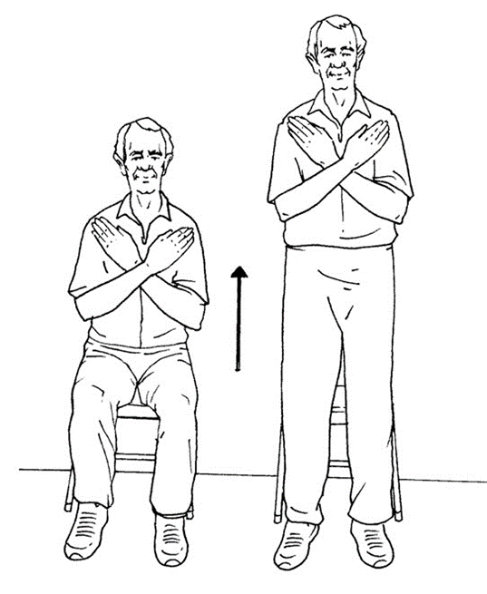

30-Secod Chair Stand

Primary focus: Lower body strength and core stability.

Why it is important: Completing this exercise on a regular basis can increase your lower body strength as well as cardiovascular strength. Lower body strength is important for getting out of a chair or car and standing from a kneeling position.

Steps to complete this exercise:
- Equipment needed: Chair (place against a wall) and a timer.

- Sit in the chair, place the timer next to you on the table. Set the timer for 30 seconds.

- Start the timer. Stand up with your arms by your side or crossed against your chest. Sit back down without using the arm rests of the chair. This is one repetition.

- If you require additional support, this exercise can be modified by using the arm rests for support as you stand and sit. With repeated practice, you may find that over time, you are able to complete this exercise without the use of arm rests.

- Count the number of times you stood to a full standing position and returned to a fully seated position in 30 seconds. If you are on your way up to stand when the time is up, give yourself credit for that stand.

- Practice the movement a few times before beginning.

- If the result feels good to you today, record it.

- Enter the number of repetitions.

Date: __________ Number of repetitions: __________
Date: __________ Number of repetitions: __________
Date: __________ Number of repetitions: __________
Date: __________ Number of repetitions: __________

fending off falls

Preventing falls by moving more

Shoulder Mobility
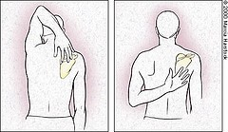
Primary focus: Upper Body Flexibility

Why it is important: Performing this movement everyday can increase shoulder flexibility and your range of motion so you can continue to reach items off a high shelf and improve posture.

Steps to complete this exercise:
- Reach up and over with right arm and reach for the tip if your shoulder blade closest to your spine on the left side (repeat with the left arm).

- Reach your right arm under your underarm and up toward the bottom tip of your opposite (left) shoulder blade on the left side. Your palm is facing away from your body. (Repeat with your left arm)

- Practice the movement. Stop if there is pain.

- If the result feels good to you today, record it.

- Circle below either the location reached or if you had pain:

Date: | Location touched when reaching arm up and over | Location touched when reaching under your underarm
Right Arm | Back of head/Neck/Middle back/Tip of shoulder blade/Pain | Side/Lower back/ Middle back/Shoulder blade/Pain
Left Arm | Back of head/Neck/ Middle back/Tip of shoulder blade/Pain | Side/Lower back/ Middle back/Shoulder blade/Pain

Date: | Location touched when reaching arm up and over | Location touched when reaching under your underarm
Right Arm | Back of head/Neck/Middle back/Tip of shoulder blade/ Pain | Side/Lower back/ Middle back/Shoulder blade/Pain
Left Arm | Back of head/Neck/Middle back/tip of Shoulder blade/Pain | Side/Lower back/Middle back/Shoulder blade/Pain

fending off falls

Session one Kaizen Step

1) Goal I want to accomplish: (example: I want to take a fitness class that will improve my balance.)

2) One step I could take toward that goal: (example: I will get the class schedule from the concierge desk.)

3) Ways I can break this step (#2) into smaller actions: (List as many actions as you can think of.)

