fending off falls

Be Mindful of Your actions

Date: _____________________

Summary:
In this session, we discussed distractions that can increase the chance of falling and learned techniques to be mindful of our movements. This included a look at specific risk factors of falling such poor sleep and grip strength, while offering supportive strategies for increasing balance and reaction time through dual-tasking exercises. We also talked about ageism and ableism and brainstormed ways to accept and support one another. Additionally, we developed strategies for overcoming the fear of falling.

“Our greatest glory is not in never falling, but in rising every time we fall.” -Confucius

NOTES:

fending off falls

Be Mindful of Your actions
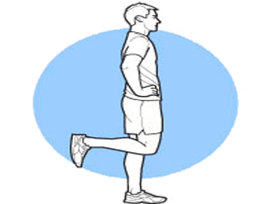

Single-leg balance

Primary focus: Static balance and proprioception (awareness of position and movement of the body).
Why it is important: This is an effective exercise for improving balance and decreasing fall risk. Working up to 20 seconds on each leg will also strengthens your brain and functional ability.
Steps to complete this exercise:
- Equipment needed: Countertop and a timer
- Stand with the countertop on your side and close enough so you can place your hand on the countertop if you start to lose your balance. (Alternatively, you can stand beside a sturdy chair for support.)
- This exercise can be modified by holding on to the countertop or chair back, continue to practice until you can balance without holding on to something for support.
- Practice the movement once by shifting your weight and balancing briefly on your left leg and then your right leg.
- Stand on one foot, repeat with the other foot. Hold for as long as you can without moving your foot or touching the chair for up to 20 seconds.
- If the result feels good to you today, record it.
- Enter the date, which leg you were standing on, and the number of seconds you held the position.
Date: | Right Leg (number of seconds) | Left Leg (number of seconds)

fending off falls

Be Mindful of Your actions

10 Tips for Better Sleep

Keep a schedule. (Stick to a sleep schedule.​)

Practice a bedtime ritual.​

Avoid naps late in the afternoon. ​

Exercise daily.

Go outside. (Natural sunlight helps regulate our circadian rhythms.) ​

Practice a relaxation technique such as meditation or a mindfulness activity.​

Declutter: Evaluate your room clutter. (Create a more peaceful environment.) ​

Choose a comfortable mattress and pillow.​

Wind down and disconnect. (Wind down 30 minutes before bed by disconnecting from devices.) ​

Avoid alcohol, caffeine and heavy food close to bedtime (3 hours). Avoid smoking altogether. ​

fending off falls

Be Mindful of Your actions

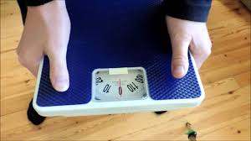
Grip Strength
Primary focus: Forearm strength
Why it is important: Grip strength is important for carrying groceries, lifting laundry baskets, opening jars, gripping a steering wheel and other daily tasks as well as swinging a golf club or holding a tennis racket. Grip strength can be predictor of mobility and cognitive abilities.
Steps to complete this exercise:
- Equipment needed: analog floor scale
- Hold the scale with both hands; the heel of your hand and thumb on the top of the scale and your fingers wrapped around on the bottom.
- Practice the movement for this exercise with each hand by squeezing the scale with your left hand, and again with your right.
- Push down or squeeze the scale as hard as you can with your left hand.
- Push down or squeeze the scale as hard as you can with your right hand.
- If the result feels good to you today, record it.
- Enter the number on the scale:

Date: __________ Right hand: ________ Left hand: ________
Date: __________ Right hand: ________ Left hand: ________
Date: __________ Right hand: ________ Left hand: ________
Date: __________ Right hand: ________ Left hand: ________

fending off falls

Session four Kaizen Step

1) Goal I want to accomplish: (example: I want to take steps toward being more aware of what I am doing.)

2) One step I could take toward that goal: (example: I will get put my phone in my purse when I am walking or driving.)

3) Ways I can break this step (#2) into smaller actions: (List as many actions as you can think of.)

